St Louis Catholic Academy, Newmarket
Part of Our Lady of Walsingham Catholic Multi Academy Trust

Christ at the Centre: Children at the Heart




St Louis Calculation Policy

Approved by the Committee/Governing Body
Signature of Chair of Governors
Signature of CEO OLOW

Review date | September 2026

MISSION STATEMENT
Our school strives to be a living Christian Community which values and nurtures each individual through a sound education and encourages responsible attitudes towards our changing world.

‘Loving to learn, learning to love’
St Louis Catholic Academy Mathematics Calculation Policy
The purpose of the policy is to:
Show how we meet the requirements of the National Curriculum 2014 for Mathematics and help children to develop their mathematics skills in age related progressive steps.
Explain how we teach mathematics calculations in school.
Explain Mastering Number (scheme used for EYFS and KS1)
Show the visual models we use across the school.
Explain to parents and carers how we teach addition, subtraction, multiplication, division and problem solving;
Show visually how bar models can help children to problem-solve.
Set out the age-related expectations for teaching mathematics, whilst recognising that children learn at different speeds outside these groupings.
Ensure that teachers have a consistent framework to follow, that supports the development of mathematics skills in small steps.
Ensure the teaching and learning for Mastery is followed in all classes.

Mathematics Mastery
Teaching for Mastery is:
Belief that all pupils can achieve.
Keeping the class working together so all can access and master mathematics.
Development of deep mathematical understanding.
Development of both factual/procedural and conceptual fluency.
Spending longer on key topics, providing time to go deeper and embed learning.

How to Use the Policy
National Curriculum year group expectations for place value, addition, subtraction, multiplication and division (from EYFS
to Year 6), including the correct mathematical vocabulary relevant to each year group.
Annex A:
Mathematical skills broken down for each year group (following the White Rose Maths Scheme of Learning, that we use at St Louis).
Annex B:
Multiplication and Division: An overview of the different models and images that support the teaching and learning of different concepts, providing explanations of benefits and showing links between different operations, and concrete, pictorial and abstract representations.
Annex C:
Addition and Subtraction: An overview of the different models and images that support the teaching and learning of different concepts, providing explanations of benefits and showing links between different operations, and concrete, pictorial and abstract representations.

Mastering Number

What is Mastering Number?
The Mastering Number project aims to secure firm foundations in the development of good number sense for all children from Reception through to Year 1 and Year 2. The aim over time is that children will leave KS1 with fluency in calculation and a confidence and flexibility with number. Attention will be given to key knowledge and understanding needed in Reception classes, and progression through KS1 to support success in the future.

How do we use Mastering Number at St Louis?

Children in Reception, Year 1 and Year 2 will receive between 10-15 minutes daily of Mastering Number.

Year 1 and 2 use Mastering Number in addition to a Maths lesson (using WRM scheme).

Children are able to use different manipulatives to show the same structure. This deepens children’s understanding of a concept. Examples of different representations are below.

Our pupils will develop their understanding of relationships of numbers, their ability to observe patterns and ability to explain their thinking.
- Children will be able to clearly communicate their mathematical ideas
- Children will develop a secure understanding and build firm mathematical foundations
- Children will develop fluency in calculation and number sense
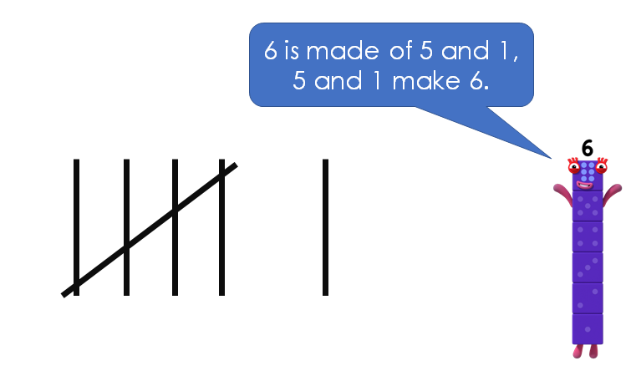
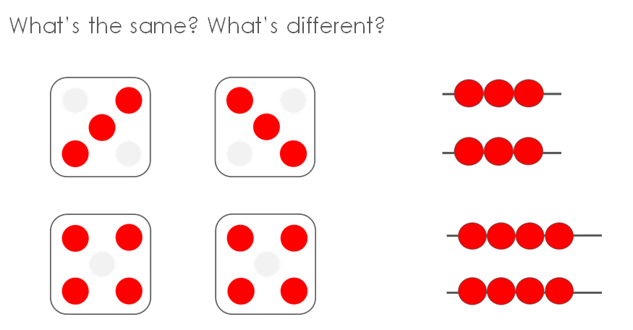
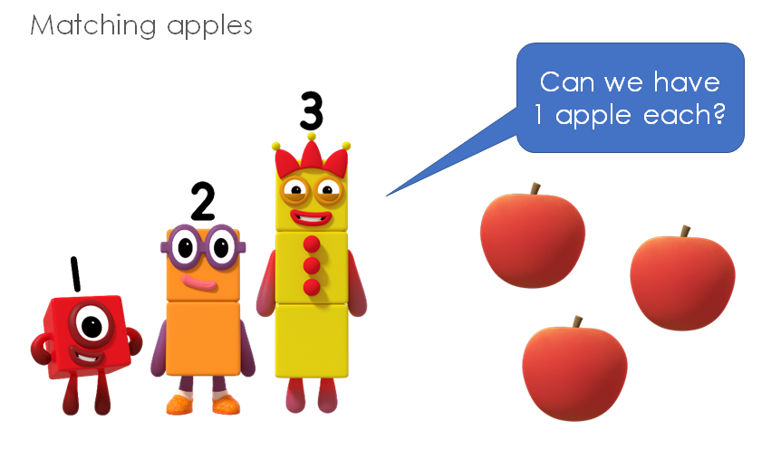
- Confidence in maths will improve and this will help children make good progress towards the Early Learning Goals and Year Group Expectations.



National Curriculum year group expectations for place value, addition, subtraction, multiplication and division (from EYFS
to Year 6).

Place value



Place value: Count

Year 1 | Year 2 | Year 3 | Year 4 | Year 5 | Year 6
- count to and across 100, forwards and backwards, beginning with 0 or 1, or from any given number  - Count numbers to 100 in numerals; count in multiples of twos, fives and tens | - count in steps of 2, 3, and 5 from 0, and in tens from any number, forward and backward | - count from 0 in multiples of 4, 8,  50 and 100; find  10 or 100 more or less than a given number | - count in multiples of 6, 7, 9, 25 and  1000  - count backwards through zero to include negative numbers | - count forwards or backwards in steps of powers of 10 for any given number up to 1 000 000  - count forwards and backwards with positive and negative whole numbers, including through zero
Autumn 1  Spring 1  Spring 3  Summer 4 | Autumn 1 | Autumn 1  Autumn 3 | Autumn 1  Autumn 4 | Autumn 1  Summer 4

Place value: Represent

Year 1 | Year 2 | Year 3 | Year 4 | Year 5 | Year 6
- identify and represent numbers using objects and pictorial representations  - read and write numbers to 100 in numerals  - read and write numbers from 1 to 20 in numerals and words | - read and write numbers to at least 100 in numerals and in words  - identify, represent and estimate numbers using different representations, including the number line | - identify, represent and estimate numbers using different representations  - read and write numbers up to 1000 in numerals and in words | - identify, represent and estimate numbers using different representations  - read Roman numerals to 100 (I to C) and know that over time, the numeral system changed to include the concept of zero and place value | - read, write, (order and compare) numbers to at least 1 000 000 and determine the value of each digit  - read Roman  numerals to 1000  (M) and recognise years written in Roman numerals | - read, write, (order and compare) numbers up to 10 000 000 and determine the value of each digit
Autumn 1  Spring 1  Spring 3  Summer 4 | Autumn 1 | Autumn 1 | Autumn 1 | Autumn 1 | Autumn 1

Place value: Use and compare

Year 1 | Year 2 | Year 3 | Year 4 | Year 5 | Year 6
- given a number, identify one more and one less | - recognise the place value of each digit in a two-digit number (tens, ones)  - compare and order numbers from 0 up to 100; use <, > and = signs | - recognise the place value of each digit in a three-digit number (hundreds, tens, ones)  - compare and order numbers up to 1000 | - find 1000 more or less than a given number  - recognise the place value of each digit in a four-digit number (thousands, hundreds, tens, and ones)  - order and compare numbers beyond 1000 | - (read, write) order and compare numbers to at least 1 000 000 and determine the value of each digit | - (read, write), order and compare numbers up to 10 000 000 and determine the value of each digit
Autumn 1  Spring 1  Spring 3  Summer 4 | Autumn 1 | Autumn 1 | Autumn 1 | Autumn 1 | Autumn 1

Place value: Problems/Rounding

Year 1 | Year 2 | Year 3 | Year 4 | Year 5 | Year 6
 | - use place value and number facts to solve problems | - solve number problems and practical problems involving these ideas | - round any number to the nearest 10, 100 or  1000  - solve number and practical problems that involve all of the above and with increasingly large positive numbers | - interpret negative numbers in context  - round any number up to 1 000 000 to the  nearest 10, 100,  1000, 10 000 and  100 000  - solve number problems and practical problems that involve all of the above | - round any whole number to a required degree of accuracy  - use negative numbers in context, and calculate intervals across zero  - solve number and practical problems that involve all of the above
 | Autumn 1 | Autumn 1 | Autumn 1 | Autumn 1 | Autumn 1

Addition and subtraction

Addition & subtraction: Calculations

Year 1 | Year 2 | Year 3 | Year 4 | Year 5 | Year 6
- add and subtract one-digit and two- digit numbers to 20, including zero | - add and subtract numbers using concrete objects, pictorial representations, and mentally, including:  - a two-digit  number and ones  - a two-digit number and tens  - two two-digit numbers  - adding three one- digit numbers | - add and subtract numbers mentally, including:  - a three-digit number and ones  - a three-digit  number and tens  - a three-digit number and hundreds  - add and subtract numbers with up to three digits, using formal written methods of columnar addition and subtraction | - add and subtract numbers with up to 4 digits using the formal written methods of columnar addition and subtraction where appropriate | - add and subtract whole numbers with more than 4 digits, including using formal written methods (columnar addition and subtraction)  - add and subtract numbers mentally with increasingly large numbers | - perform mental calculations, including with mixed operations and large numbers  - use their knowledge of the order of operations to carry out calculations involving the four operations
Autumn 2  Spring 2 | Autumn 2 | Autumn 2 | Autumn 2 | Autumn 2 | Autumn 2

Addition & subtraction: Problems

Year 1 | Year 2 | Year 3 | Year 4 | Year 5 | Year 6
- solve one-step problems that involve addition and subtraction, using concrete objects and pictorial representations, and missing number problems such as 7 =  – 9 | - solve problems with addition and subtraction:  - using concrete objects and pictorial representations, including those involving numbers, quantities and measures  - applying their increasing knowledge of mental and written methods | - solve problems, including missing number problems, using number facts, place value, and more complex addition and subtraction | - solve addition and subtraction two- step problems in contexts, deciding which operations and methods to use and why | - solve addition and subtraction multi- step problems in contexts, deciding which operations and methods to use and why  - solve problems involving addition, subtraction, multiplication and division and a combination of these, including understanding the meaning of the equals sign | - solve addition and subtraction multi- step problems in contexts, deciding which operations and methods to use and why
Autumn 2  Spring 2 | Autumn 2 | Autumn 2 | Autumn 2 | Autumn 2 | Autumn 2

Multiplication and
division

Multiplication & division: Recall/Use

Year 1 | Year 2 | Year 3 | Year 4 | Year 5 | Year 6
 | - recall and use multiplication and division facts for the 2, 5 and 10 multiplication tables, including recognising odd and even numbers  - show that multiplication of two numbers can be done in any order (commutative) and division of one number by another cannot | - recall and use multiplication and division facts for the 3, 4 and 8 multiplication tables | - recall multiplication and division facts for multiplication tables up to 12 × 12  - use place value, known and derived facts to multiply and divide mentally, including: multiplying by 0 and 1; dividing by 1; multiplying together three numbers  - recognise and use factor pairs and commutativity in mental calculations | - identify multiples and factors, including finding all factor pairs of a number, and common factors of two numbers  - know and use the vocabulary of prime numbers, prime factors and composite (non- prime) numbers  - establish whether a number up to 100 is prime and recall prime numbers up to 19  - recognise and use square numbers and cube numbers, and the notation for squared (2) and  cubed (3) | - identify common factors, common multiples and prime numbers  - use estimation to check answers to calculations and determine, in the context of a problem, an appropriate degree of accuracy
 | Spring 2 | Autumn 3  Spring 1 | Autumn 4  Spring 1 | Autumn 3 | Autumn 2

Multiplication & division: Calculations

Year 1 | Year 2 | Year 3 | Year 4 | Year 5 | Year 6
 | - calculate mathematical statements for multiplication and division within the multiplication tables and write them using the multiplication (×), division (÷) and equals (=) signs | - write and calculate mathematical statements for multiplication and division using the multiplication tables that they know, including for two-digit numbers times one-digit numbers, using mental and progressing to formal written methods | - multiply two-digit and three-digit numbers by a one-digit number using formal written layout | - multiply numbers up to 4 digits by a one- or two-digit number using a formal written method, including long multiplication for two- digit numbers  - multiply and divide numbers mentally drawing upon known facts  - divide numbers up to 4 digits by a one-digit number using the formal written method of short division and interpret remainders appropriately for the context  - multiply and divide whole numbers and those involving decimals by 10, 100  and 1000 | - multiply multi-digit numbers up to 4 digits by a two-digit whole number using the formal written method of long multiplication  - divide numbers up to 4 digits by a two-digit whole number using the formal written method of long division, and interpret remainders as whole number remainders, fractions, or by rounding, as appropriate for the context  - divide numbers up to 4 digits by a two-digit number using the formal written method of short division where appropriate, interpreting remainders according to the context  - perform mental calculations, including with mixed operations and large numbers
 | Spring 2 | Autumn 3  Spring 1 | Spring 1 | Autumn 3  Spring 1 | Autumn 2

Multiplication & division: Problems

Year 1 | Year 2 | Year 3 | Year 4 | Year 5 | Year 6
- solve one-step problems involving multiplication and division, by calculating the answer using concrete objects, pictorial representations and arrays with the support of the teacher | - solve problems involving multiplication and division, using materials, arrays, repeated addition, mental methods, and multiplication and division facts, including problems in contexts | - solve problems, including missing number problems, involving multiplication and division, including positive integer scaling problems and correspondence problems in which n objects are connected to m objects | - solve problems involving multiplying and adding, including using the distributive law to multiply two digit numbers by one digit, integer scaling problems and harder correspondence problems such as n objects are connected to m objects | - solve problems involving multiplication and division including using their knowledge of factors and multiples, squares and cubes  - solve problems involving multiplication and division, including scaling by simple fractions and problems involving simple rates | - solve problems involving addition, subtraction, multiplication and division
Summer 1 | Spring 2 | Spring 1 | Spring 1 | Autumn 3  Spring 1 | Autumn 2

Multiplication & division: Combined

Year 1 | Year 2 | Year 3 | Year 4 | Year 5 | Year 6
 |  |  |  | - solve problems involving addition, subtraction, multiplication and division and a combination of these, including understanding the meaning of the equals sign | - use their knowledge of the order of operations to carry out calculations involving the four operations
 |  |  |  | Spring 1 | Autumn 2

Fractions, decimals, percentages

Fractions: Recognise and write

Year 1 | Year 2 | Year 3 | Year 4 | Year 5 | Year 6
- recognise, find and name a half as one of two equal parts of an object, shape or quantity  - recognise, find and name a quarter as one of four equal parts of an object, shape or quantity | - recognise, find, name and write fractions ¹ , 1 , 2  3 4 4  and ³ of a length,  4  shape, set of  objects or  quantity | - count up and down in tenths; recognise that tenths arise from dividing an object into 10 equal parts and in dividing one-digit numbers or quantities by 10  - recognise, find and write fractions of a discrete set of objects: unit fractions and non- unit fractions with small denominators  - recognise and use fractions as numbers: unit fractions and non- unit fractions with small denominators | - count up and down in hundredths; recognise that hundredths arise when dividing an object by one hundred and dividing tenths by ten. | - identify, name and write equivalent fractions of a given fraction, represented visually, including tenths and hundredths  - recognise mixed numbers and improper fractions and convert from one form to the other and write mathematical statements > 1 as a mixed number  [for example, ² +  5  ⁴ = 6 = 1 1]  5 5 5
Summer 2 | Summer 1 | Spring 3 | Spring 4  Summer 1 | Autumn 4

Fractions: Compare

Year 1 | Year 2 | Year 3 | Year 4 | Year 5 | Year 6
 | - Recognise the equivalence of ²  4  and ¹  2 | - recognise and show, using diagrams, equivalent fractions with small denominators  - compare and order unit fractions, and fractions with the same denominators | - recognise and show, using diagrams, families of common equivalent fractions | - compare and order fractions whose denominators are all multiples of the same number | - use common factors to simplify fractions; use common multiples to express fractions in the same denomination  - compare and order fractions, including fractions  > 1
 | Summer 1 | Spring 3 | Spring 3 | Autumn 4 | Autumn 3

Fractions: Calculations

Year 1 | Year 2 | Year 3 | Year 4 | Year 5 | Year 6
 | - write simple fractions for  example, ¹ of 6 =  2  3 | - add and subtract fractions with the same denominator within one whole  [for example, ⁵ +  7  1 = 6]  7 7 | - add and subtract fractions with the same denominator | - add and subtract fractions with the same denominator and denominators that are multiples of the same number  - multiply proper fractions and mixed numbers by whole numbers, supported by materials and diagrams | - add and subtract fractions with different denominators and mixed numbers, using the concept of equivalent fractions  - multiply simple pairs of proper fractions, writing the answer in its simplest form [for example,¹ × 1 = 1]  4 2 8  - divide proper  fractions by whole numbers [for example ¹ ÷ 2 = 1 ]  3 6
 | Summer 1 | Summer 1 | Spring 3 | Autumn 4  Spring 2 | Autumn 3  Autumn 4

Fractions: Solve problems

Year 1 | Year 2 | Year 3 | Year 4 | Year 5 | Year 6
 |  | - solve problems that involve all of the above | - solve problems involving increasingly harder fractions to calculate quantities, and fractions to divide quantities, including non-unit fractions where the answer is a whole number
 |  | Spring 3  Summer 1 | Spring 3

Decimals: Recognise, write, compare

Year 1 | Year 2 | Year 3 | Year 4 | Year 5 | Year 6
 |  |  | - recognise and write decimal equivalents of any number of tenths or hundredths  - recognise and write decimal equivalents to  1 , 1 , 3  4 2 4  - round decimals  with one decimal place to the nearest whole number  - compare numbers with the same number of decimal places up to two decimal places | - read and write decimal numbers as fractions [for example, 0.71 =  71 ]  100  - recognise and use  thousandths and relate them to tenths, hundredths and decimal equivalents  - round decimals with two decimal places to the nearest whole number and to one decimal place  - read, write, order and compare numbers with up to three decimal places | - identify the value of each digit in numbers given to three decimal places
 |  |  | Spring 4  Summer 1 | Spring 3  Summer 3 | Spring 3

Fractions, decimals and percentages

Year 1 | Year 2 | Year 3 | Year 4 | Year 5 | Year 6
 |  |  | - solve simple measure and money problems involving fractions and decimals to two decimal places | - recognise the per cent symbol (%) and understand that per cent relates to ‘number of parts per hundred’, and write percentages as a fraction with denominator 100, and as a decimal  - solve problems which require knowing percentage and decimal equivalents of  ¹ , 1 , 1 , 2 , 4 and  2 4 5 5 5  those fractions  with a denominator of a multiple of 10 or 25 | - associate a fraction with division and calculate decimal fraction equivalents [for example, 0.375] for a simple fraction [for  example, ³]  8  - recall and use  equivalences between simple fractions, decimals and percentages, including in different contexts
 |  |  | Spring 3  Spring 4 Summer1 | Spring 3 | Spring 3  Spring 4

Ratio and proportion, algebra

Ratio and proportion

Year 1 | Year 2 | Year 3 | Year 4 | Year 5 | Year 6
- solve problems involving the relative sizes of two quantities where missing values can be found by using integer multiplication and division facts
- solve problems involving the calculation/use of percentages for comparison
- solve problems involving similar shapes where the scale factor is known or can be found
- solve problems involving unequal sharing and grouping using knowledge of fractions and multiples
 |  |  |  |  | Spring 1

Algebra

Year 1 | Year 2 | Year 3 | Year 4 | Year 5 | Year 6
- solve one-step problems that involve addition and subtraction, using concrete objects and pictorial representations, and missing number problems such as 7 =  – 9 | - recognise and use the inverse relationship between addition and subtraction and use this to check calculations and solve missing number problems | - solve problems, including missing number problems |  |  | - use simple formulae  - generate and describe linear number sequences  - express missing number problems algebraically  - find pairs of numbers that satisfy an equation with two unknowns  - enumerate possibilities of combinations of two variables
 |  |  |  |  | Spring 2

Note – although formal algebraic notation is not introduced until Y6, algebraic thinking starts much earlier as exemplified by the ‘missing number’ objectives from Y1/2/3

Measurement

Using measures

Year 1 | Year 2 | Year 3 | Year 4 | Year 5 | Year 6
- compare, describe and solve practical problems for:  - lengths and heights  - mass/weight  - capacity and  volume  - time  - measure and begin to record the following:  - lengths and heights  - mass/weight  - capacity and volume  - time (hours, minutes, seconds) | - choose and use appropriate standard units to estimate and measure length/height in any direction (m/cm); mass (kg/g); temperature (℃); capacity (litres/ml) to the nearest appropriate unit, using rulers, scales, thermometers and measuring vessels  - compare and order lengths, mass, volume/capacity and record the results using >, < and = | - measure, compare, add and subtract: lengths (m/cm/mm); mass (kg/g); volume/capacity (l/ml) | - Convert between different units of measure [for example, kilometre to metre; hour to minute]  - estimate, compare and calculate different measures | - convert between different units of metric measure  - understand and use approximate equivalences between metric units and common imperial units such as inches, pounds and pints  - use all four operations to solve problems involving measure [for example, length, mass, volume, money] using decimal notation, including scaling | - solve problems involving the calculation and conversion of units of measure, using decimal notation up to 3  d.p. where  appropriate  - use, read, write and convert between standard units, converting measurements of length, mass, volume and time from a smaller unit of measure to a larger unit, and vice versa, using decimal notation to up to 3 d.p.  - convert between miles and kilometres
Spring 4  Spring 5  Summer 6 | Spring 3  Spring 4 | Spring 2  Spring 4 | Spring 2  Summer 3 | Spring 4  Summer 5  Summer 6 | Autumn 5

Money

Year 1 | Year 2 | Year 3 | Year 4 | Year 5 | Year 6
- recognise and know the value of different denominations of coins and notes | - recognise and use symbols for pounds (£) and pence (p); combine amounts to make a particular value  - find different combinations of coins that equal the same amounts of money  - solve simple problems in a practical context involving addition and subtraction of money of the same unit, including giving change | - add and subtract amounts of money to give change, using both £ and p in practical contexts | - estimate, compare and calculate different measures, including money in pounds and pence | - use all four operations to solve problems involving measure [for example, money]
Summer 5 | Spring 1 | Summer 2 | Summer 2 | Summer 3

Time

Year 1 | Year 2 | Year 3 | Year 4 | Year 5 | Year 6
- sequence events in chronological order using language [for example, before and after, next, first, today, yesterday, tomorrow, morning, afternoon and evening]  - recognise and use language relating to dates, including days of the week, weeks, months and years  - tell the time to the hour and half past the hour and draw the hands on a clock face to show these times | - compare and sequence intervals of time  - tell and write the time to five minutes, including quarter past/to the hour and draw the hands on a clock face to show these times  - know the number of minutes in an hour and the number of hours in a day | - tell and write the time from an analogue clock, including using Roman numerals from I to XII, and 12- hour and 24-hour clocks  - estimate and read time with increasing accuracy to the nearest minute; record and compare time in terms of seconds, minutes and hours; use vocabulary such as o’clock, a.m./p.m., morning, afternoon, noon and midnight  - know the number of seconds in a minute and the number of days in each month, year and leap year  - compare durations of events [for example to calculate the time taken by particular events or tasks] | - read, write and convert time between analogue and digital 12- and 24-hour clocks  - solve problems involving converting from hours to minutes; minutes to seconds; years to months; weeks to days | - solve problems involving converting between units of time | - use, read, write and convert between standard units, converting measurements of time from a smaller unit of measure to a larger unit, and vice versa  Note – In the WRM schemes, time conversions are covered in Y5; the Y6 block concentrates on metric units.
Summer 6 | Summer 2 | Summer 3 | Summer 3 | Summer 5 | Autumn 5

Perimeter, area, volume

Year 1 | Year 2 | Year 3 | Year 4 | Year 5 | Year 6
 |  | - measure the perimeter of simple 2-D shapes | - measure and calculate the perimeter of a rectilinear figure (including squares) in centimetres and metres  - find the area of rectilinear shapes by counting squares | - measure and calculate the perimeter of composite rectilinear shapes in centimetres and metres  - calculate and compare the area of rectangles (including squares) and including using standard units, square centimetres (cm2) and square metres (m2) and estimate the area of irregular shapes  - estimate volume [for example, using blocks to build cuboids] and capacity [for example, using water] | - recognise that shapes with the same areas can have different perimeters and vice versa  - recognise when it is possible to use formulae for area and volume of shapes  - calculate the area of parallelograms and triangles  - calculate, estimate and compare volume of cubes and cuboids using standard units, including cubic centimetres (cm3) and cubic metres (m3), and extending to other units
 |  | Spring 2 | Autumn 3  Spring 2 | Spring 4  Summer 6 | Spring 5

Geometry

2-D shapes

Year 1 | Year 2 | Year 3 | Year 4 | Year 5 | Year 6
- recognise and name common 2- D shapes [for example, rectangles (including squares), circles and triangles] | - identify and describe the properties of 2-D shapes, including the number of sides and line symmetry in a vertical line  - identify 2-D shapes on the surface of 3-D shapes, [for example, a circle on a cylinder and a triangle on a pyramid]  - compare and sort common 2-D shapes and everyday objects | - draw 2-D shapes | - compare and classify geometric shapes, including quadrilaterals and triangles, based on their properties and sizes  - identify lines of symmetry in 2-D shapes presented in different orientations | - distinguish between regular and irregular polygons based on reasoning about equal sides and angles.  - use the properties of rectangles to deduce related facts and find missing lengths and angles | - draw 2-D shapes using given dimensions and angles  - compare and classify geometric shapes based on their properties and sizes  - illustrate and name parts of circles, including radius, diameter and circumference and know that the diameter is twice the radius
Autumn 3 | Autumn 3 | Summer 4 | Summer 4 | Summer 1 | Summer 1

3-D shapes

Year 1 | Year 2 | Year 3 | Year 4 | Year 5 | Year 6
- recognise and name common 3- D shapes [for example, cuboids (including cubes), pyramids and spheres] | - recognise and name common 3- D shapes [for example, cuboids (including cubes), pyramids and spheres]  - compare and sort common 3-D shapes and everyday objects | - make 3-D shapes using modelling materials; recognise 3-D shapes in different orientations and describe them |  | - identify 3-D shapes, including cubes and other cuboids, from 2-D representations | - recognise, describe and build simple 3-D shapes, including making nets
Autumn 3 | Autumn 3 | Summer 4 |  | Summer 1 | Summer 1

Angles and lines

Year 1 | Year 2 | Year 3 | Year 4 | Year 5 | Year 6
 |  | - recognise angles as a property of shape or a description of a turn  - identify right angles, recognise that two right angles make a half-turn, three make three quarters of a turn and four a complete turn; identify whether angles are greater than or less than a right angle  - identify horizontal and vertical lines and pairs of perpendicular and parallel lines | - identify acute and obtuse angles and compare and order angles up to two right angles by size  - identify lines of symmetry in 2-D shapes presented in different orientations  - complete a simple symmetric figure with respect to a specific line of symmetry | - know angles are measured in degrees: estimate and compare acute, obtuse and reflex angles  - draw given angles, and measure them in degrees  - identify:  - angles at a point and one whole turn (total 360°)  - angles at a point  on a straight line  and ¹ a turn (total  2  180°)  - other multiples of 90° | - find unknown angles in any triangles, quadrilaterals, and regular polygons  - recognise angles where they meet at a point, are on a straight line, or are vertically opposite, and find missing angles
 |  | Summer 4 | Summer 4 | Summer 2 | Summer 1

Position and direction

Year 1 | Year 2 | Year 3 | Year 4 | Year 5 | Year 6
- describe position, direction and movement, including whole, half, quarter and three-quarter turns | - order and arrange combinations of mathematical objects in patterns and sequences  - use mathematical vocabulary to describe position, direction and movement, including movement in a straight line and distinguishing between rotation as a turn and in terms of right angles for quarter, half and three-quarter turns (clockwise and anti- clockwise) |  | - describe positions on a 2-D grid as coordinates in the first quadrant  - describe movements between positions as translations of a given unit to the left/right and up/down  - plot specified points and draw sides to complete a given polygon | - identify, describe and represent the position of a shape following a reflection or translation, using the appropriate language, and know that the shape has not changed | - describe positions on the full coordinate grid (all four quadrants)  - draw and translate simple shapes on the coordinate plane, and reflect them in the axes
Summer 3 | Summer 4 |  | Summer 6 | Summer 2 | Summer 2

Statistics

Present and interpret data

Year 1 | Year 2 | Year 3 | Year 4 | Year 5 | Year 6
 | - interpret and construct simple pictograms, tally charts, block diagrams and simple tables | - interpret and present data using bar charts, pictograms and tables | - interpret and present discrete and continuous data using appropriate graphical methods, including bar charts and time graphs | - complete, read and interpret information in tables, including timetables | - interpret and construct pie charts and line graphs and use these to solve problems
 | Summer 3 | Summer 5 | Summer 5 | Spring 5 | Spring 6

Solve statistical problems

Year 1 | Year 2 | Year 3 | Year 4 | Year 5 | Year 6
 | - ask and answer simple questions by counting the number of objects in each category and sorting the categories by quantity  - ask and answer questions about totalling and comparing categorical data | - solve one-step and two-step questions [for example, ‘How many more?’ and ‘How many fewer?’] using information presented in scaled bar charts and pictograms and tables | - solve comparison, sum and difference problems using information presented in bar charts, pictograms, tables and other graphs | - solve comparison, sum and difference problems using information presented in a line graph | - calculate and interpret the mean as an average
 | Summer 3 | Summer 5 | Summer 5 | Spring 5 | Spring 6

