Annex A


Addition

Skill | Year | Representations and models
Add two 1-digit numbers to 10 | 1 | Part-whole model Bar model Number shapes | Ten frames (within 10) Bead strings (10) Number tracks
Add 1 and 2-digit numbers to 20 | 1 | Part-whole model Bar model Number shapes  Ten frames (within 20) | Bead strings (20) Number tracks Number lines (labelled) Straws
Add three 1-digit  numbers | 2 | Part-whole model  Bar model | Ten frames (within 20)  Number shapes
Add 1 and 2-digit numbers to 100 | 2 | Part-whole model Bar model  Number lines (labelled) | Number lines (blank) Straws  Hundred square

Skill | Year | Representations and models
Add two 2-digit numbers | 2 | Part-whole model Bar model  Number lines (blank) Straws | Base 10  Place value counters
Add with up to 3-digits | 3 | Part-whole model Bar model | Base 10  Place value counters Column addition
Add with up to 4-digits | 4 | Part-whole model  Bar model | Base 10  Place value counters  Column addition
Add with more than 4 digits | 5 | Part-whole model Bar model | Place value counters Column addition
Add with up to 3 decimal places | 5 | Part-whole model Bar model | Place value counters Column addition

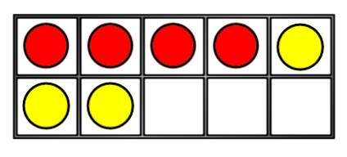
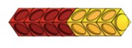
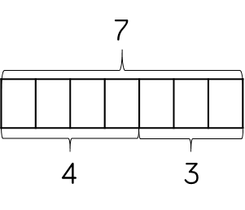


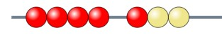
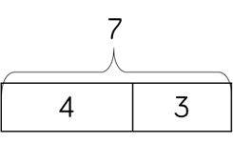
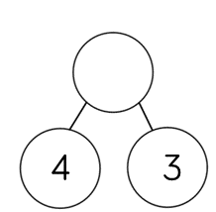
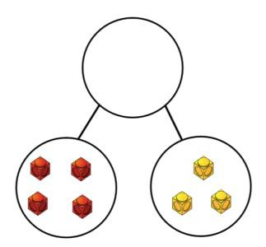
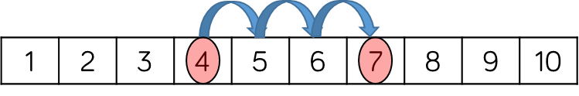
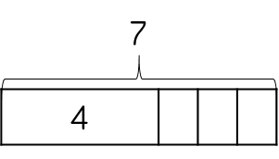




Skill: Add 1-digit numbers within 10 | Year: 1
4 + 3 = 7 | When adding numbers to 10, children can explore both aggregation and augmentation.  The part-whole model, discrete and continuous bar model, number shapes and ten frame support aggregation.  The combination bar model, ten frame, bead string and number track all support augmentation.

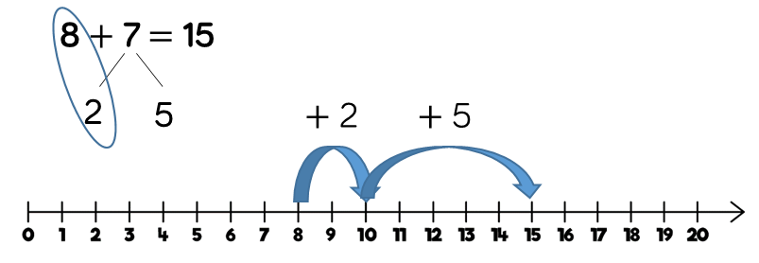
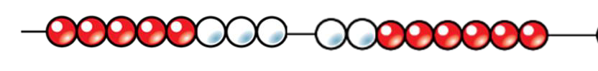
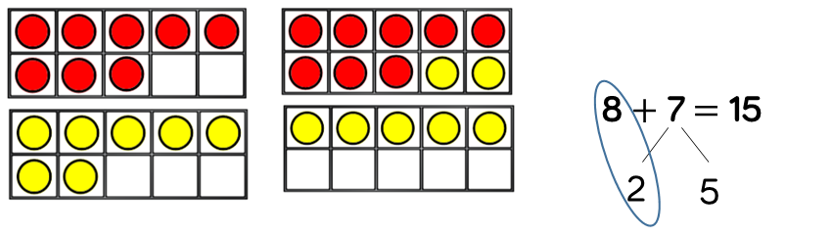
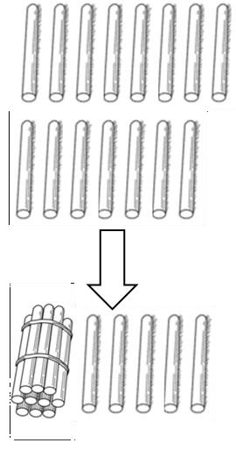
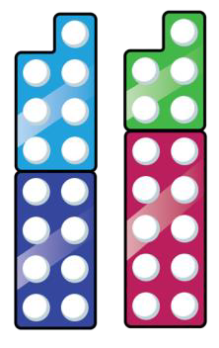
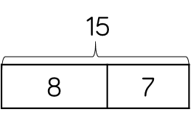
Skill: Add 1 and 2-digit numbers to 20 | Year: 1/2
7  8  8 + 7 = 15 | When adding one- digit numbers that cross 10, it is important to highlight the importance of ten ones equalling one ten. In Year 1, this is only done just by counting on. From Year 2, use different manipulatives can be used to represent this exchange alongside number lines to support children in understanding how to partition their jumps.

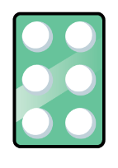



Skill: Add three 1-digit numbers |  |  |  |  |  |  |  |  | Year: 2
16  7 6 3  7 + 6 + 3 = 16 |  |  |  |  |  |  |  |  | When adding three 1- digit numbers, children should be encouraged to look for number bonds to 10 or doubles to add the numbers more efficiently.  This supports children in their understanding of commutativity.  Manipulatives that highlight number bonds to 10 are effective when adding three 1-digit numbers.
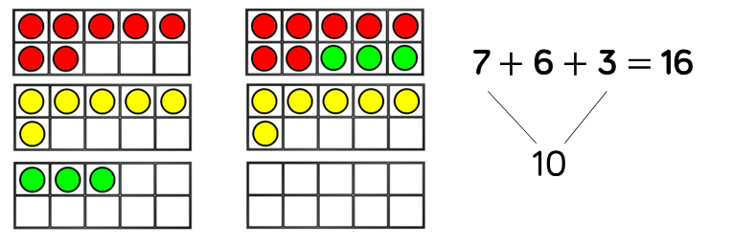
 |  |  |  |  |  |  | 16

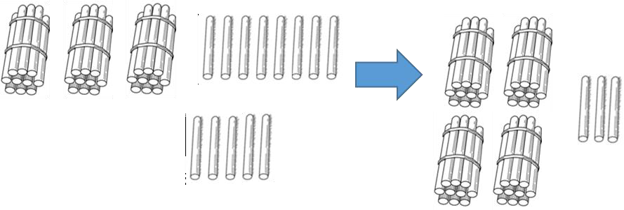
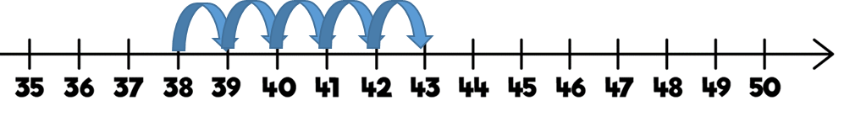
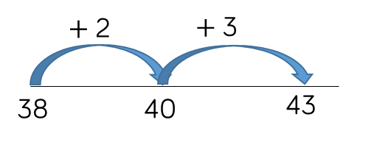
Skill: Add 1-digit and 2-digit numbers to 100 |  |  | Year: 2/3
 | 38 |  | When adding single digits to a two-digit
 |  |  | number, children
 |  |  | should be
 | 5 |  | encouraged to count on from the larger
 | ? |  | number.
38 |  | 38 + 5 = 43  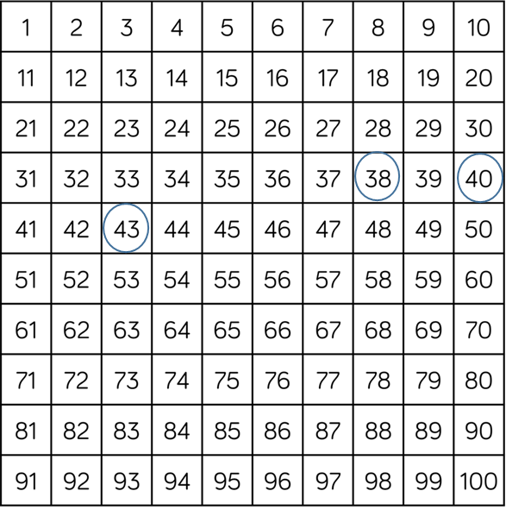 | They should also apply their knowledge of number bonds to add more efficiently  e.g. 8 + 5 = 13 so 38  + 5 = 43.  Hundred squares and straws can support children to find the number bond to 10.

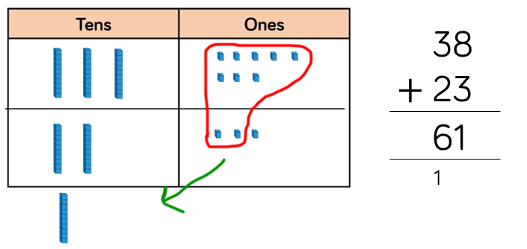
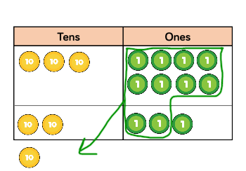
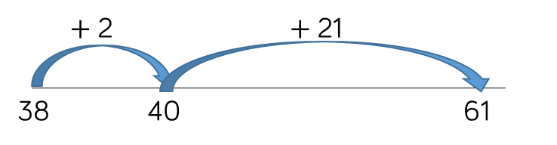
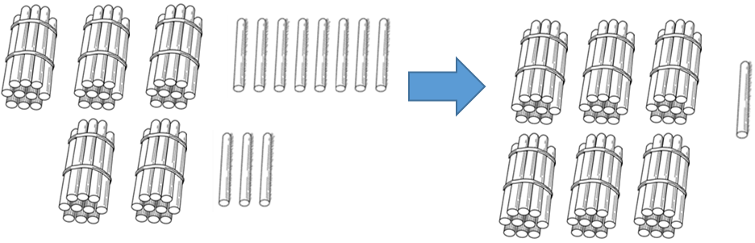
Skill: Add two 2-digit numbers to 100

38

23

?
38 + 23 = 61
23
38

Year: 2/3
Children can use a blank number line and other representations to count on to find the total. Encourage them to jump to multiples of 10 to become more efficient.
From Year 3, encourage children to use the formal column method when calculating alongside straws, base 10 or place value counters. As numbers become larger, straws become less efficient.

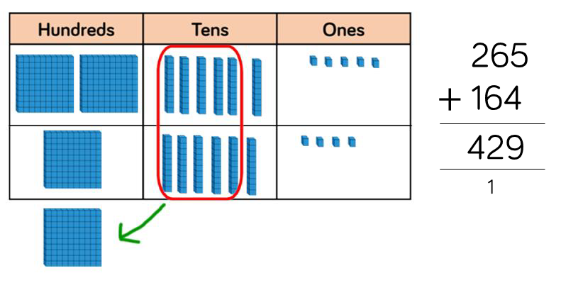
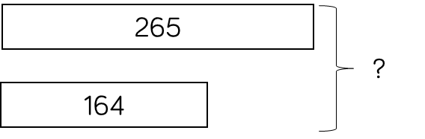
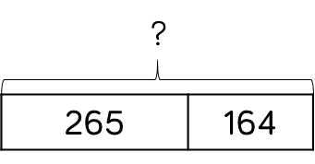
Skill: Add numbers with up to 3 digits |  |  | Year: 3
 | 265 |  | Base 10 and place value counters are the most effective
? | 164 |  | manipulatives when adding numbers with up to 3 digits.
 |  |  | Ensure children write
 |  | 265 + 164 = 429 | out their calculation alongside any
 |  | 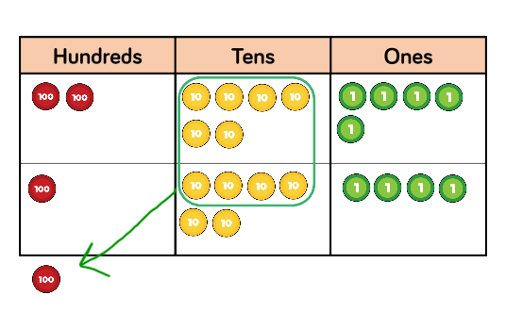 | concrete resources so they can see the links to the written column method.  Plain counters on a place value grid can also be used to support learning.

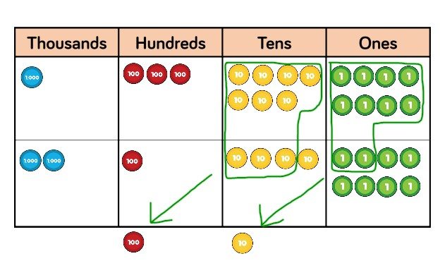
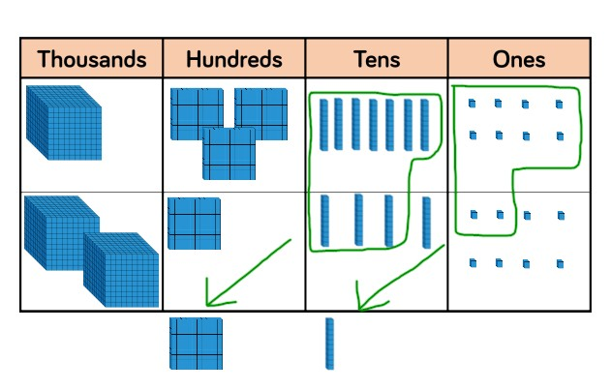
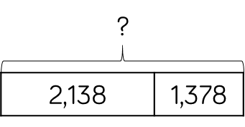
 | 1 | 3 | 7 | 8
+ | 2 | 1 | 4 | 8
 | 3 | 5 | 2 | 6

Skill: Add numbers with up to 4 digits | Year: 4
1,378  ?  2,148 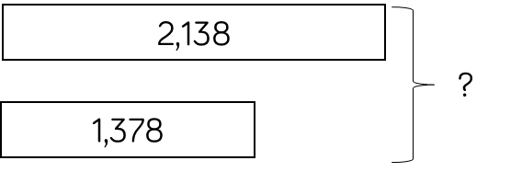 1 1  1,378 + 2,148 = 3,526 | Base 10 and place value counters are the most effective manipulatives when adding numbers with up to 4 digits.  Ensure children write out their calculation alongside any concrete resources so they can see the links to the written column method.  Plain counters on a place value grid can also be used to support learning.

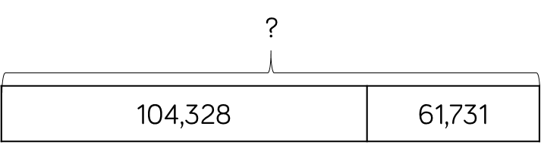
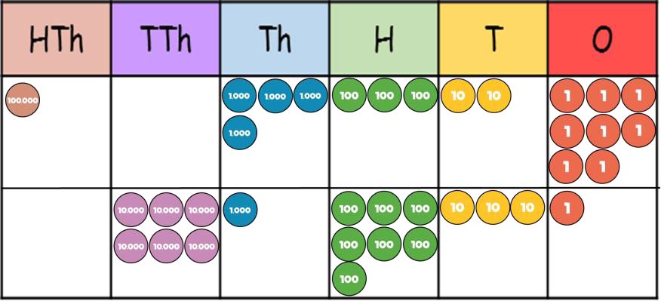
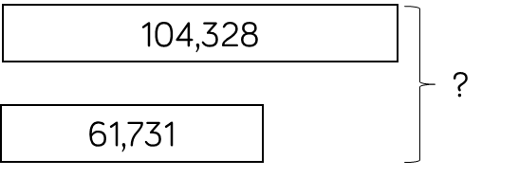
Skill: Add numbers with more than 4 digits |  |  | Year: 5/6
 |  |  | Place value counters
 | ? |  | or plain counters on a place value grid are
 |  |  | the most effective
 |  |  | concrete resources
104,328 |  | 61,731 | when adding numbers with more
 |  |  | than 4 digits.
 |  | 104,328 + 61,731 = 166,059 | At this stage, children  should be
 |  | 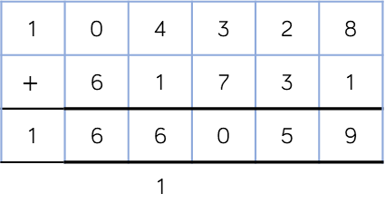 | encouraged to work in the abstract, using the column method to add larger numbers efficiently.

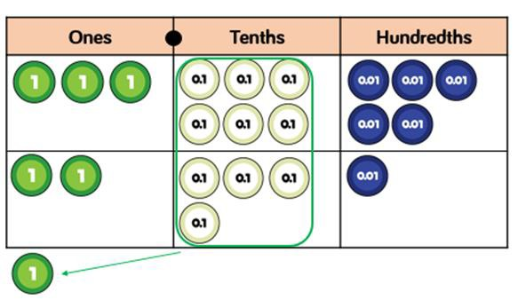
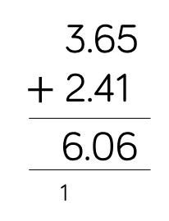
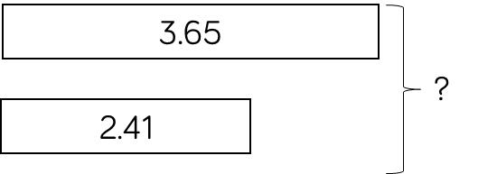
Skill: Add with up to 3 decimal places |  |  |  | Year: 5
2.41 |  | 3.65 | ?  3.65 2.41 | Place value counters and plain counters on a place value grid are the most effective
 |  |  |  | manipulatives when
 | ? |  |  | adding decimals with 1, 2 and then 3
 |  |  |  | decimal places.
 |  |  | 3.65 + 2.41 = 6.06  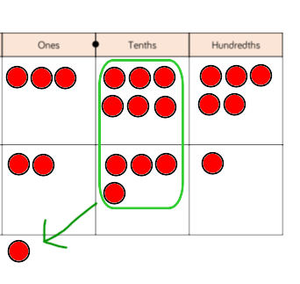 | Ensure children have experience of adding decimals with a variety of decimal places. This includes putting this into context when adding money and other measures.

Subtraction

Skill | Year | Representations and models
Subtract two 1-digit numbers to 10 | 1 | Part-whole model Bar model Number shapes | Ten frames (within 10) Bead strings (10) Number tracks
Subtract 1 and 2-digit  numbers to 20 | 1 | Part-whole model Bar model Number shapes  Ten frames (within 20) | Bead string (20) Number tracks Number lines (labelled) Straws
Subtract 1 and 2-digit  numbers to 100 | 2 | Part-whole model  Bar model  Number lines (labelled) | Number lines (blank)  Straws  Hundred square
Subtract two 2-digit  numbers | 2 | Part-whole model Bar model  Number lines (blank)  Straws | Base 10  Place value counters

Skill | Year | Representations and models
Subtract with up to 3- digits | 3 | Part-whole model Bar model | Base 10  Place value counters Column subtraction
Subtract with up to 4- digits | 4 | Part-whole model Bar model | Base 10  Place value counters Column subtraction
Subtract with more than 4 digits | 5 | Part-whole model Bar model | Place value counters Column subtraction
Subtract with up to 3 decimal places | 5 | Part-whole model Bar model | Place value counters Column subtraction

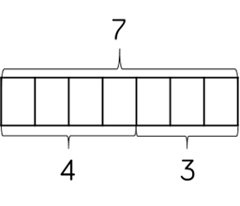
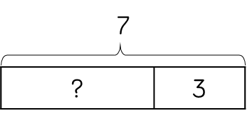
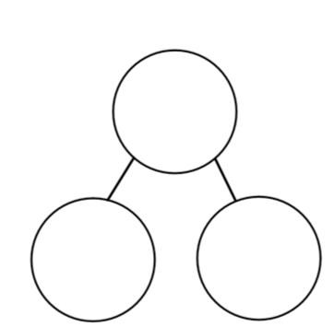
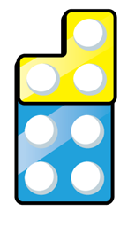
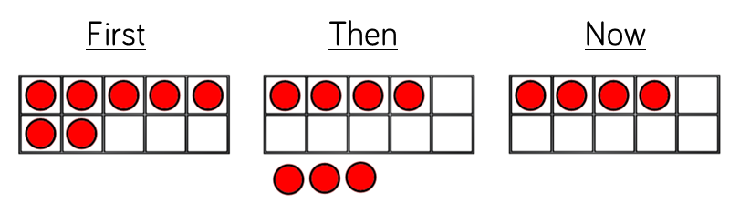
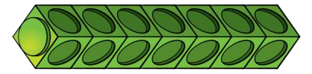
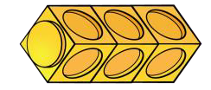
Skill: Subtract 1-digit numbers within 10 |  |  |  | Year: 1
 |  |  |  | Part-whole models,
 | 7 |  |  | bar models, ten frames and number
? |  | 3 | 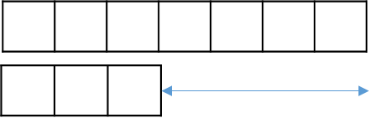 | shapes support partitioning.  Ten frames, number tracks, single bar
 |  |  | 7 − 3 = 4 | models and bead strings support reduction.
 |  |  |  | Cubes and bar
 |  |  |  | models with two bars
? |  |  |  | can support finding the difference.
 |  |  | 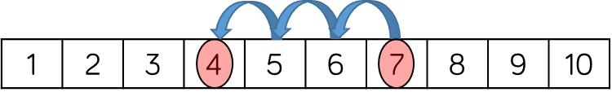

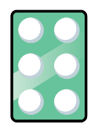
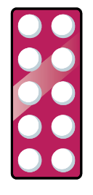

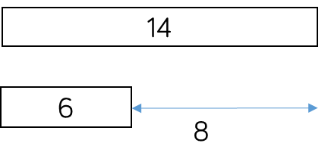
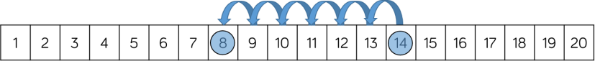
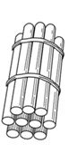
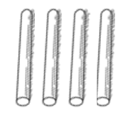

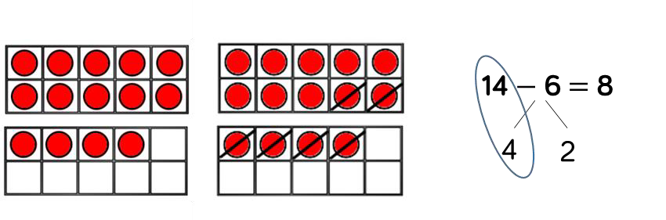
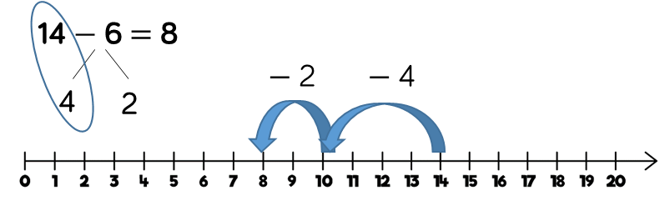
Skill: Subtract 1 and 2-digit numbers to 20 |  |  | Year: 1/2
6 | 14 |  | In Year 1, subtracting one-digit numbers that cross 10, is done by counting back,
 |  | 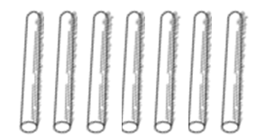 | using objects, number tracks and number lines. From Year 2,  children should be
 |  | 14 − 6 = 8 | encouraged to find the number bond to
 |  |  | 10 when partitioning
 |  |  | the subtracted number. Ten frames, number shapes and number lines are particularly useful for this.

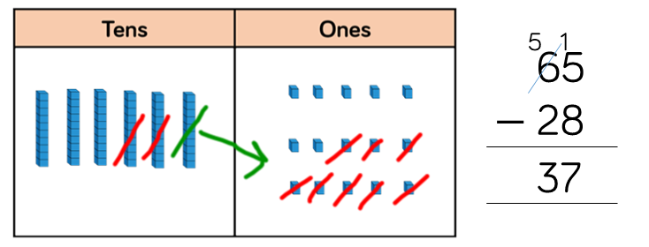
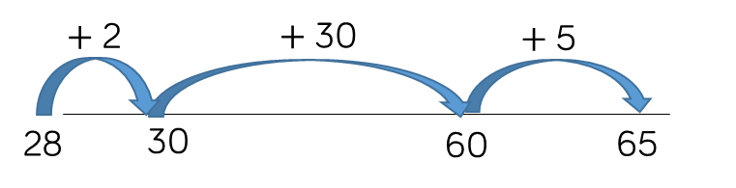
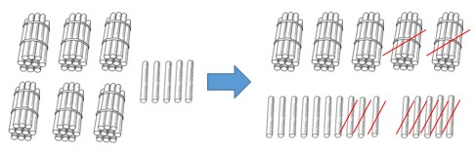
Skill: Subtract 1 and 2-digit numbers to 100 |  |  |  |  | Year: 2/3
 |  |  |  |  | Children can also use
 |  |  |  |  | a blank number line
65 |  | 28 |  |  | to count back to find the difference.  Encourage them to
 |  |  |  |  | jump to multiples of
 |  | 65 |  |  | 10 to become more efficient.
 | ? |  | 28 | 65 − 28 = 37 | From Year 3, encourage children to
 |  |  |  |  | use the formal
 |  |  |  | 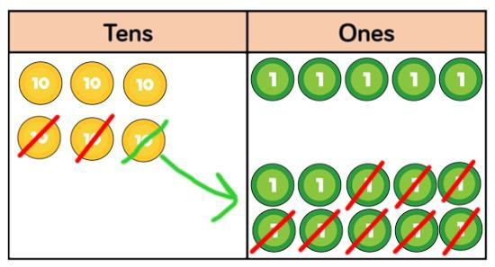 | column method when calculating alongside straws, base 10 or place value counters. As numbers become larger, straws become less efficient.

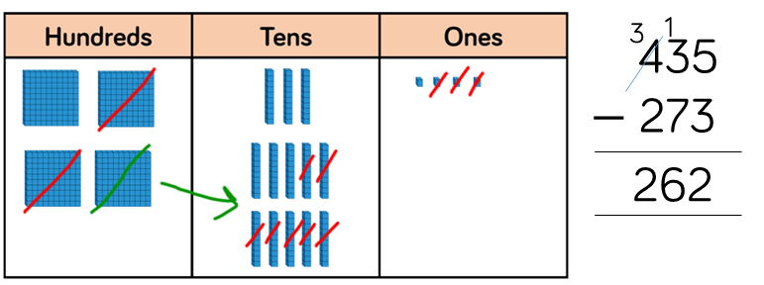
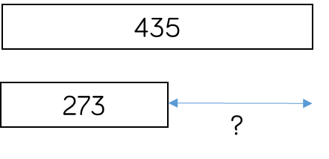
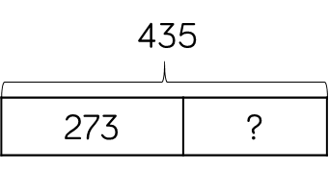
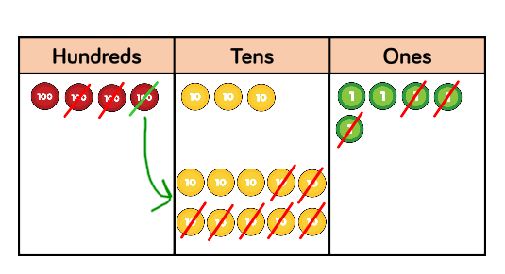
Skill: Subtract numbers with up to 3 digits |  |  |  | Year: 3
 |  |  |  | Base 10 and place
 | 435 |  |  | value counters are the most effective
 |  |  |  | manipulative when
273 |  | ? |  | subtracting numbers with up to 3 digits.
 |  |  |  | Ensure children write
 |  |  | 435 − 273 = 162 | out their calculation alongside any concrete resources so
 |  |  |  | they can see the links
 |  |  |  | to the written column
 |  |  |  | method.
 |  |  | 162 | Plain counters on a place value grid can
 |  |  |  | also be used to
 |  |  |  | support learning.

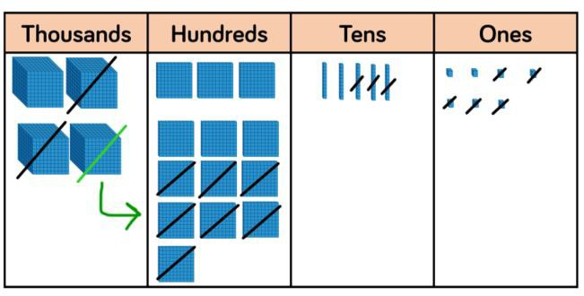
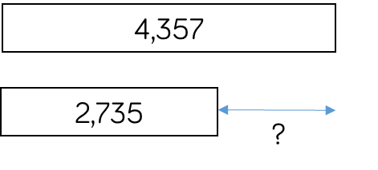
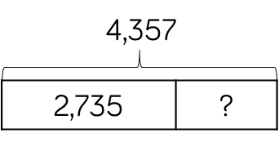
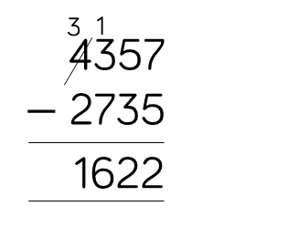
Skill: Subtract numbers with up to 4 digits |  |  |  | Year: 4
 |  |  |  | Base 10 and place
 | 4,357 |  |  | value counters are the most effective
 |  |  |  | manipulatives when
 |  |  |  | subtracting numbers
2,735 |  | ? |  | with up to 4 digits.
 |  |  |  | Ensure children write
 |  |  | 4,357 − 2,735 = 1,622 | out their calculation alongside any concrete resources so
 |  |  | 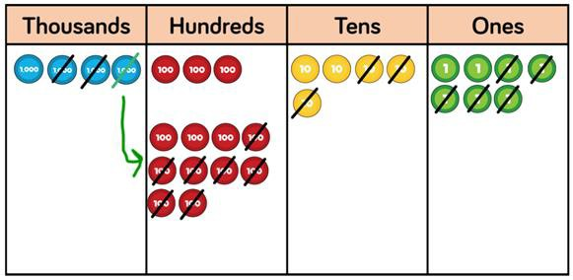 | they can see the links to the written column method.  Plain counters on a place value grid can also be used to support learning.

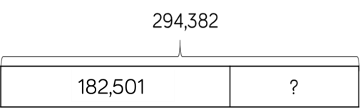
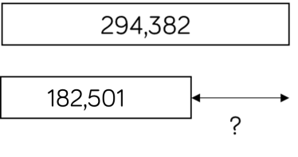
Skill: Subtract numbers with more than 4 digits | Year: 5/6
 | Place value counters
294,382 | or plain counters on a place value grid are
 | the most effective
 | concrete resource
182,501 ? | when subtracting numbers with more
 | than 4 digits.
294,382 − 182,501 = 111,881 | At this stage, children  should be
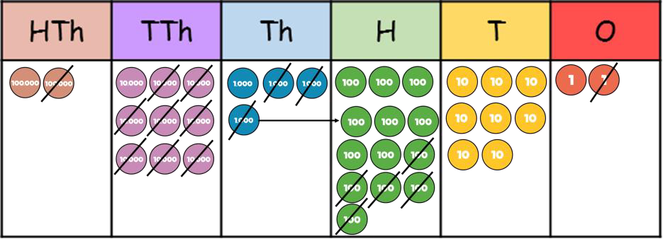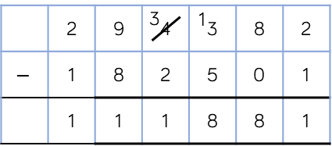 | encouraged to work in the abstract, using column method to subtract larger numbers efficiently.

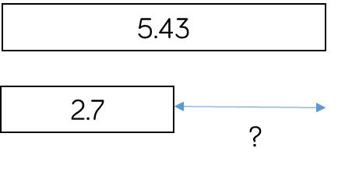
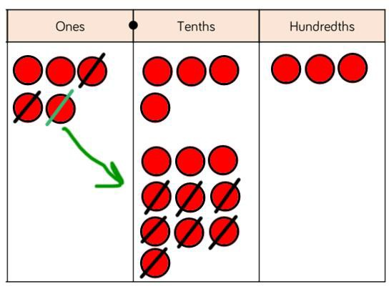
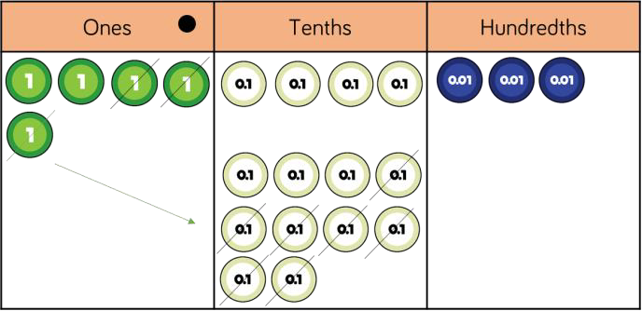
Skill: Subtract with up to 3 decimal places |  |  |  |  | Year: 5/6
2.7 | 5.43 | ? | 5.43  2.7 ?  5.43 − 2.7 = 2.73 | 4 1  5.43  − 2.7  2.73 | Place value counters
 |  |  |  |  | and plain counters on
 |  |  |  |  | a place value grid are
 |  |  |  |  | the most effective
 |  |  |  |  | manipulative when
 |  |  |  |  | subtracting decimals
 |  |  |  |  | with 1, 2 and then 3
 |  |  |  |  | decimal places.
 |  |  |  |  | Ensure children have
 |  |  |  |  | experience of
 |  |  |  |  | subtracting decimals
 |  |  |  |  | with a variety of
 |  |  |  |  | decimal places. This
 |  |  |  |  | includes putting this
 |  |  |  |  | into context when
 |  |  |  |  | subtracting money
 |  |  |  |  | and other measures.

Glossary

Addend - A number to be added to another.

Aggregation - combining two or more quantities or
measures to find a total.

Augmentation - increasing a quantity or measure by another quantity.

Commutative – numbers can be added in any order.

Complement – in addition, a number and its complement make a total e.g. 300 is the complement to 700 to make 1,000

Difference – the numerical difference between two numbers is found by comparing the quantity in each group.

Exchange – Change a number or expression for another of an equal value.
Minuend – A quantity or number from which another is subtracted.

Partitioning – Splitting a number into its component parts.

Reduction – Subtraction as take away.

Subitise – Instantly recognise the number of objects
in a small group without needing to count.

Subtrahend - A number to be subtracted from another.

Sum - The result of an addition.

Times Tables

Skill | Year | Representations and models
Recall and use |  | Bar model | Ten frames
multiplication and division facts for the | 2 | Number shapes Counters | Bead strings Number lines
2-times table |  | Money | Everyday objects
Recall and use |  | Bar model | Ten frames
multiplication and division facts for the | 2 | Number shapes Counters | Bead strings Number lines
5-times table |  | Money | Everyday objects
Recall and use |  | Hundred square | Ten frames
multiplication and division facts for the | 2 | Number shapes Counters | Bead strings Number lines
10-times table |  | Money | Base 10

Skill | Year | Representations and models
Recall and use multiplication and division facts for the 3-times table | 3 | Hundred square Number shapes Counters | Bead strings Number lines Everyday objects
Recall and use multiplication and division facts for the 4-times table | 3 | Hundred square Number shapes Counters | Bead strings Number lines Everyday objects
Recall and use multiplication and division facts for the 8-times table | 3 | Hundred square Number shapes | Bead strings Number tracks Everyday objects
Recall and use multiplication and division facts for the 6-times table | 4 | Hundred square  Number shapes | Bead strings Number tracks Everyday objects

Skill | Year | Representations and models
Recall and use multiplication and division facts for the 7-times table | 4 | Hundred square Number shapes | Bead strings Number lines
Recall and use multiplication and division facts for the 9-times table | 4 | Hundred square Number shapes | Bead strings Number lines
Recall and use multiplication and division facts for the 11-times table | 4 | Hundred square Base 10 | Place value counters Number lines
Recall and use multiplication and division facts for the 12-times table | 4 | Hundred square  Base 10 | Place value counters  Number lines

Skill: 2 times table | Year: 2
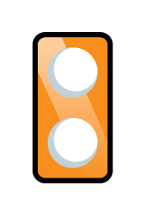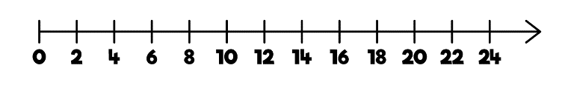  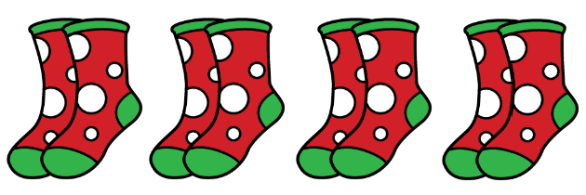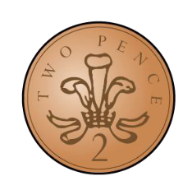  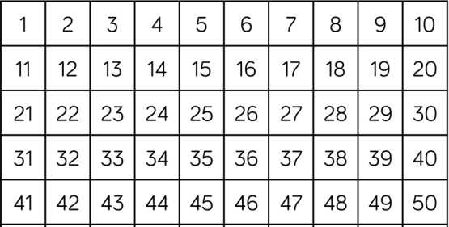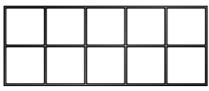  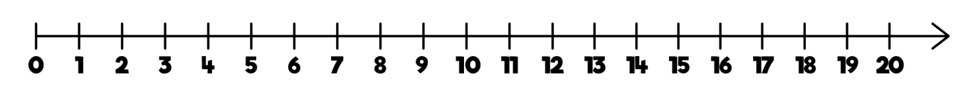 | Encourage daily counting in multiples both forwards and backwards. This can be supported using a number line or a hundred square.  Look for patterns in the two times table, using concrete manipulatives to support. Notice how all the numbers are even and there is a pattern in the ones.  Use different models  to develop fluency.

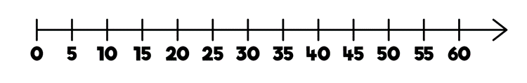

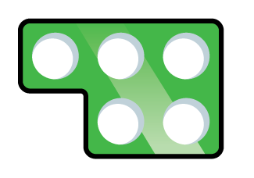
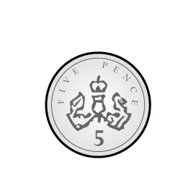
Skill: 5 times table | Year: 2
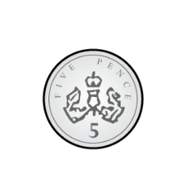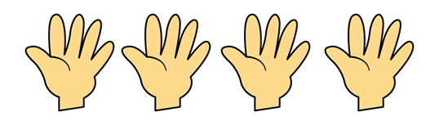 | Encourage daily counting in multiples both forwards and backwards. This can be supported using a number line or a hundred square.  Look for patterns in the five times table, using concrete manipulatives to support. Notice the pattern in the ones as well as highlighting the odd, even, odd, even pattern.

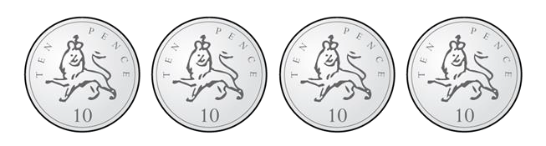
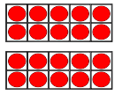
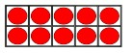


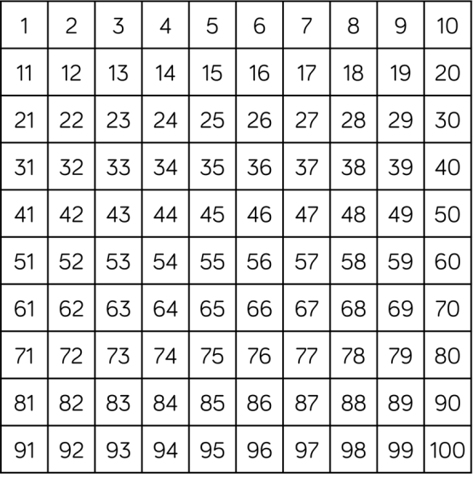

Skill: 10 times table | Year: 2
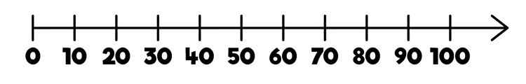 | Encourage daily counting in multiples both forwards and backwards. This can be supported using a number line or a hundred square.  Look for patterns in the ten times table, using concrete manipulatives to support. Notice the pattern in the digits- the ones are always 0, and the tens increase by 1 ten each time.


Skill: 3 times table | Year: 3
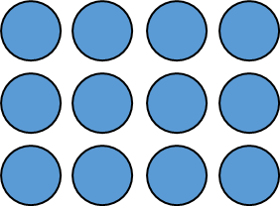  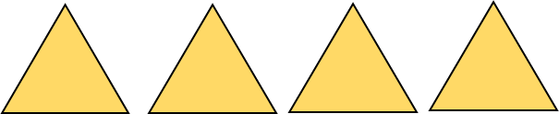  3 6 9 12    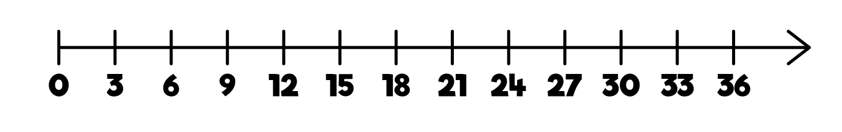 | Encourage daily counting in multiples both forwards and backwards. This can be supported using a number line or a hundred square.  Look for patterns in the three times table, using concrete manipulatives to support. Notice the odd, even, odd, even pattern using number shapes to support.  Highlight the pattern in the ones using a hundred square.

Skill: 4 times table |  |  |  |  | Year: 3
 |  |  |  | 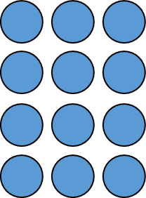  4 8 12 16 | Encourage daily counting in multiples, supported by a number line or a hundred square.  Look for patterns in the four times table, using manipulatives to support. Make links to the 2 times table, seeing how each multiple is double the twos. Notice the pattern in the ones within each group of five multiples.  Highlight that all the multiples are even using number shapes to support.

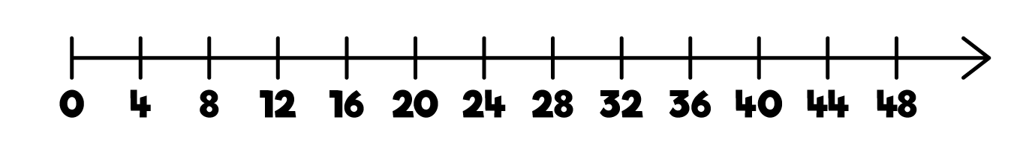
4 | 8 | 12 | 16 | 20
24 | 28 | 32 | 36 | 40
44 | 48 | 52 | 56 | 60





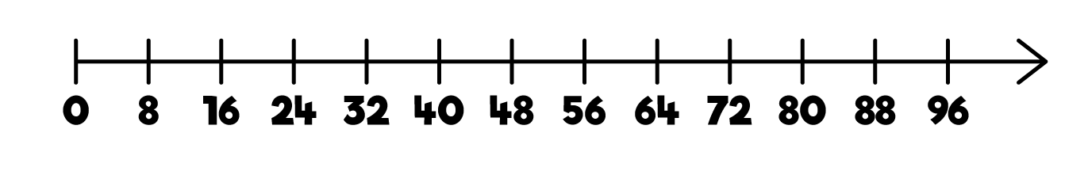
8 | 16 | 24 | 32 | 40
48 | 56 | 64 | 72 | 80

Skill: 8 times table |  |  |  |  | Year: 3
8 | 16 |  | 24 | 32 | Encourage daily counting in multiples, supported by a number line or a hundred square.  Look for patterns in the eight times table, using manipulatives to support. Make links to the 4 times table, seeing how each multiple is double the fours. Notice the pattern in the ones within each group of five multiples.  Highlight that all the multiples are even using number shapes to support.
 |  |  |  | 

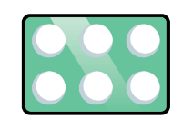

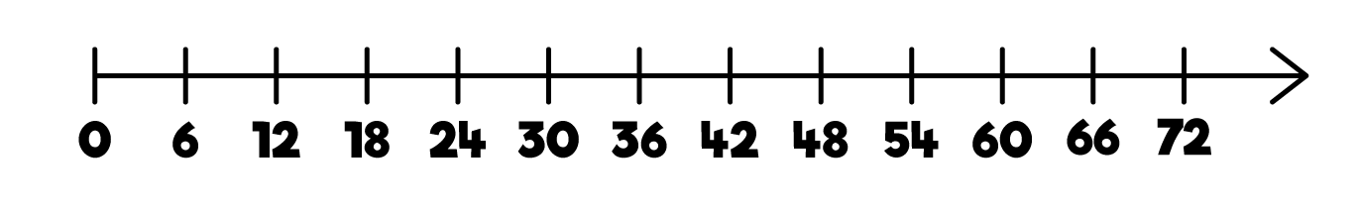

6 | 12 | 18 | 24 | 30
36 | 42 | 48 | 54 | 60
66 | 72 | 78 | 84 | 90

Skill: 6 times table |  |  |  |  | Year: 4
 |  |  |  |  | Encourage daily counting in multiples, supported by a number line or a hundred square.  Look for patterns in the six times table, using manipulatives to support. Make links to the 3 times table, seeing how each multiple is double the threes. Notice the pattern in the ones within each group of five multiples.  Highlight that all the multiples are even using number shapes to support.
 |  |  |  | 

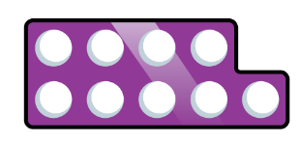

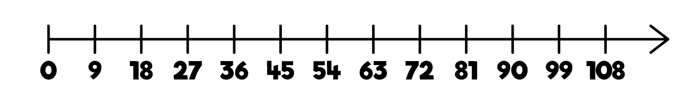
9 | 18 | 27 | 36 | 45
54 | 63 | 72 | 81 | 90

Skill: 9 times table |  |  |  |  | Year: 4
Encourage daily counting in multiples both forwards and backwards. This can be supported using a number line or a hundred square.
Look for patterns in the nine times table, using concrete manipulatives to support. Notice the pattern in the tens and ones using the hundred square to support as well as noting the odd, even pattern within the multiples.
 |  |  |  | 

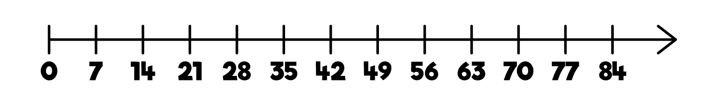


7 | 14 | 21 | 28 | 35
42 | 49 | 56 | 63 | 70

Skill: 7 times table |  |  |  |  | Year: 4
Encourage daily counting in multiples both forwards and backwards, supported by a number line or a hundred square.
The seven times table can be trickier to learn due to the lack of obvious pattern in the numbers, however they already know several facts due to commutativity.
Children can still see the odd, even pattern in the multiples using number shapes to support.

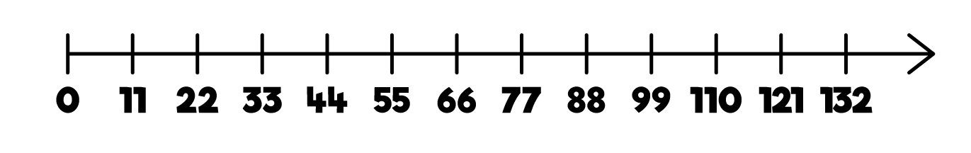



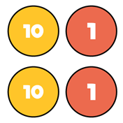

11 | 22 | 33 | 44 | 55 | 66
77 | 88 | 99 | 110 | 121 | 132

Skill: 11 times table |  |  |  |  |  | Year: 4
Encourage daily counting in multiples both forwards and backwards. This can be supported using a number line or a hundred square.

Look for patterns in the eleven times table, using concrete manipulatives to support. Notice the pattern in the tens and ones using the hundred square to support. Also consider the pattern after crossing 100
 |  |  |  | 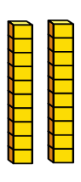 | 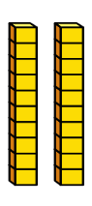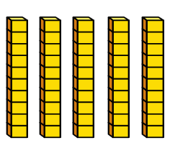

Skill: 12 times table |  |  |  |  | Year: 4
Encourage daily counting in multiples, supported by a number line or a hundred square.
Look for patterns in the 12 times table, using manipulatives to support. Make links to the 6 times table, seeing how each multiple is double the sixes. Notice the pattern in the ones within each group of five multiples. The hundred square can support in highlighting this pattern.
 |  |  |  |   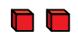
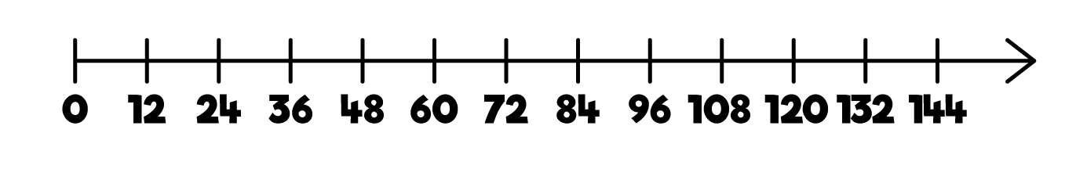
12 | 24 | 36 | 48 | 60
72 | 84 | 96 | 108 | 120
132 | 144

Multiplication

Skill | Year | Representations and models
Solve one-step problems with multiplication | 1/2 | Bar model Number shapes Counters | Ten frames Bead strings Number lines
Multiply 2-digit by 1- digit numbers | 3/4 | Place value counters Base 10 | Expanded written method Short written method
Multiply 3-digit by 1- digit numbers | 4 | Place value counters Base 10 | Short written method
Multiply 4-digit by 1-  digit numbers | 5 | Place value counters | Short written method

Skill | Year | Representations and models
Multiply 2-digit by 2-  digit numbers | 5 | Place value counters  Base 10 | Short written method  Grid method
Multiply 2-digit by 3- digit numbers | 5 | Place value counters | Short written method Grid method
Multiply 2-digit by 4- digit numbers | 5/6 | Formal written method



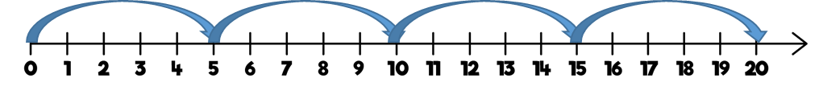
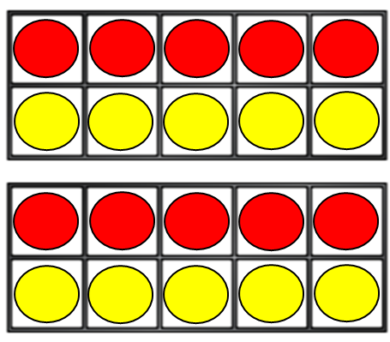
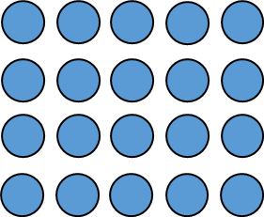
Skill: Solve 1-step problems using multiplication | Year: 1/2
One bag holds 5 apples.  How many apples do 4 bags hold?  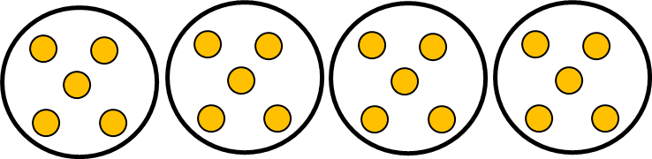  5 + 5 + 5 + 5 = 20  4 × 5 = 20  5 × 4 = 20 | Children represent multiplication as repeated addition in many different ways.  In Year 1, children use concrete and pictorial representations to solve problems. They are not expected to record multiplication formally.  In Year 2, children are introduced to the multiplication symbol.

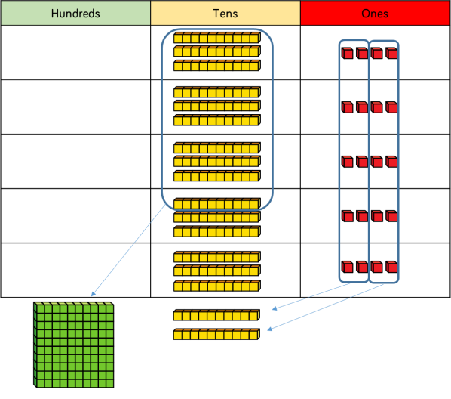
Skill: Multiply 2-digit numbers by 1-digit numbers | Year: 3/4
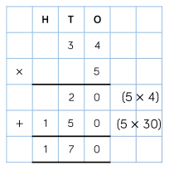  34 × 5 = 170  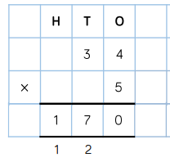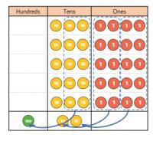 | Informal methods and the expanded method are used in Year 3 before moving on to the short multiplication method in Year 4.  Place value counters should be used to support the understanding of the method rather than supporting the multiplication, as children should use times table knowledge.

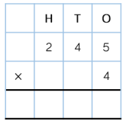
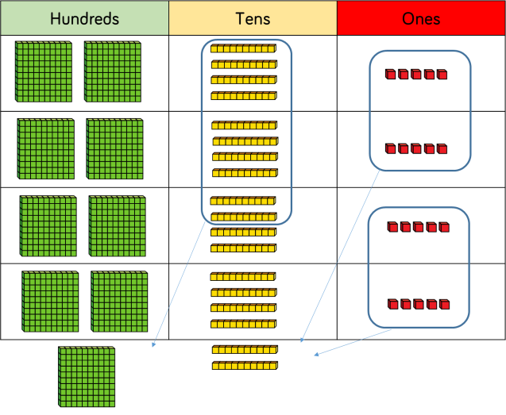
Skill: Multiply 3-digit numbers by 1-digit numbers | Year: 4
9 8 0  1 2  245 × 4 = 980  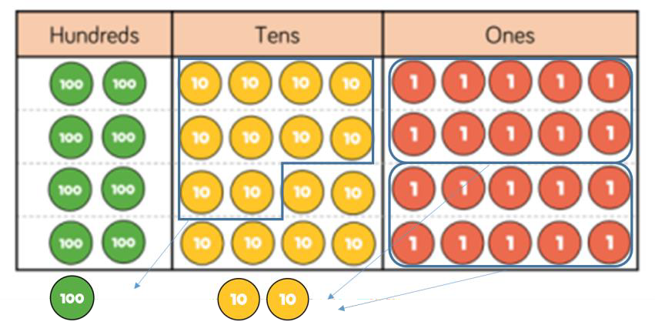 | When moving to 3- digit by 1-digit multiplication, encourage children to move towards the short, formal written method.  Base 10 and place value counters continue to support the understanding of the written method. Limit the number of exchanges needed in the questions and move children away from resources when multiplying larger numbers.

 | Th | H | T | O
 | 1 | 8 | 2 | 6
× |  |  |  | 3
 | 5 | 4 | 7 | 8

Skill: Multiply 4-digit numbers by 1-digit numbers | Year: 5
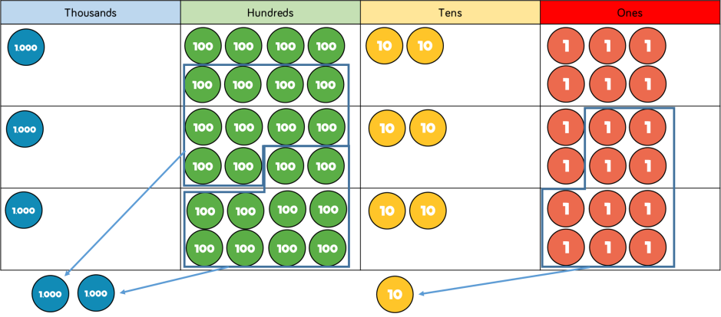  1,826 × 3 = 5,478  2 1 | When multiplying 4- digit numbers, place value counters are the best manipulative to use to support children in their understanding of the formal written method.  If children are multiplying larger numbers and struggling with their times tables, encourage the use of multiplication grids so children can focus on the use of the written method.

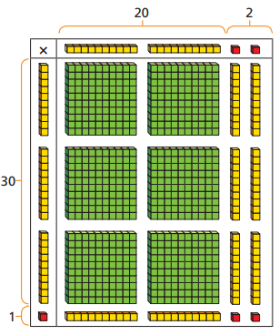
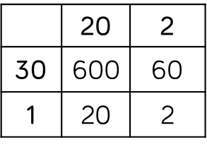
 | H | T | O
 |  | 2 | 2
× |  | 3 | 1
 |  | 2 | 2
 | 6 | 6 | 0
 | 6 | 8 | 2

Skill: Multiply 2-digit numbers by 2-digit numbers | Year: 5
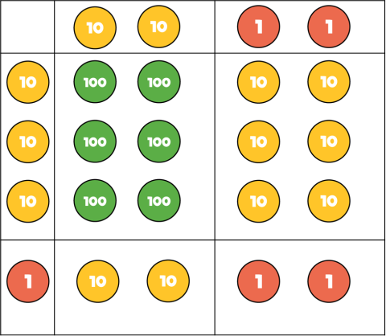  ×  22 × 31 = 682 | When multiplying a multi-digit number by 2-digits, use the area model to help children understand the size of the numbers they are using. This links to finding the area of a rectangle by finding the space covered by the Base 10.  The grid method matches the area model as an initial written method before moving on to the formal written multiplication method.

Th | H | T | O
 | 2 | 3 | 4
× |  | 3 | 2
 | 4 | 6 | 8
1 7 | 1 0 | 2 | 0
7 | 4 | 8 | 8

Skill: Multiply 3-digit numbers by 2-digit numbers | Year: 5
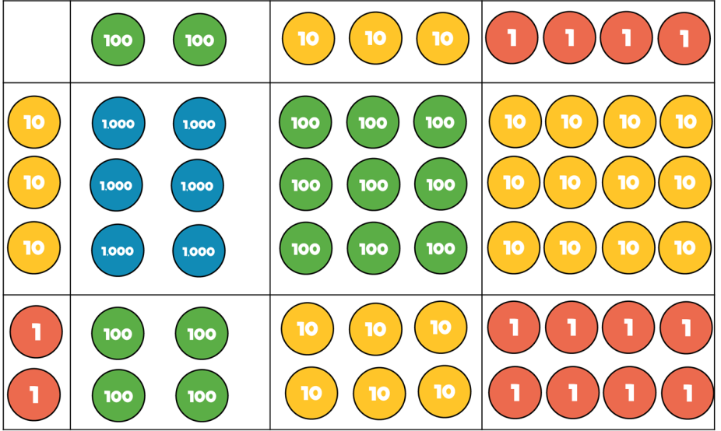  234 × 32 = 7,488 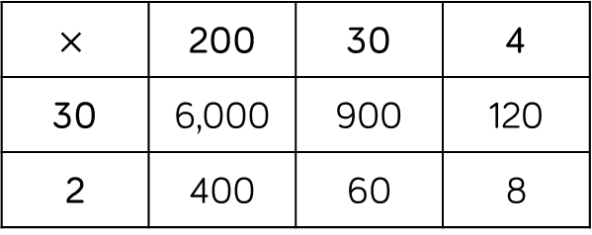 | Children can continue to use the area model when multiplying 3- digits by 2-digits.  Place value counters become more efficient to use but Base 10 can be used to highlight the size of numbers.  Children should now move towards the formal written method, seeing the links with the grid method.

TTh | Th | H | T | O
 | 2 | 7 | 3 | 9
× |  |  | 2 | 8
2  2 | 1  5 | 9  3 | 1  7 | 2
5  1 | 4 | 7  1 | 8 | 0
7 | 6 | 6 | 9 | 2

Skill: Multiply 4-digit numbers by 2-digit numbers | Year: 5/6
1  2,739 × 28 = 76,692 | When multiplying 4- digits by 2-digits, children should be confident in using the formal written method.  If they are still struggling with times tables, provide multiplication grids to support when they are focusing on the use of the method.  Consider where exchanged digits are placed and make sure this is consistent.

Division

Skill | Year | Representations and models
Solve one-step problems with division (sharing) | 1/2 | Bar model Real life objects | Arrays Counters
Solve one-step problems with division (grouping) | 1/2 | Real life objects Number shapes Bead strings Ten frames | Number lines Arrays Counters
Divide 2-digits by 1- digit (no exchange sharing) | 3 | Straws Base 10 Bar model | Place value counters  Part-whole model
Divide 2-digits by 1- digit (sharing with exchange) | 3 | Straws Base 10 Bar model | Place value counters Part-whole model

Skill | Year | Representations and models
Divide 2-digits by 1- digit (sharing with remainders) | 3/4 | Straws Base 10 Bar model | Place value counters Part-whole model
Divide 2-digits by 1-  digit (grouping) | 4/5 | Place value counters  Counters | Place value grid  Written short division
Divide 3-digits by 1- digit (sharing with exchange) | 4 | Base 10 Bar model | Place value counters Part-whole model
Divide 3-digits by 1-  digit (grouping) | 4/5 | Place value counters  Counters | Place value grid  Written short division

Skill | Year | Representations and models
Divide 4-digits by 1- digit (grouping) | 5 | Place value counters Counters | Place value grid Written short division
Divide multi-digits by 2-digits (short division) | 6 | Written short division | List of multiples
Divide multi-digits by 2-digits (long division) | 6 | Written long division | List of multiples

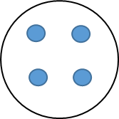
Skill: Solve 1-step problems using multiplication (sharing) |  |  | Year: 1/2
20   ? ? ?  There are 20 apples altogether.  They are shared equally between 5 bags.  How many apples are in each bag?  20 ÷ 5 = 4 | ? | ? | Children solve problems by sharing amounts into equal groups.
 | ? | ? | In Year 1, children use concrete and pictorial representations to solve problems. They are not expected to record division formally.
 | ? | ? | In Year 2, children are introduced to the division symbol.

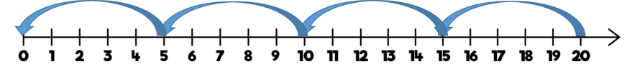
Skill: Solve 1-step problems using division (grouping) | Year: 1/2
There are 20 apples altogether.  They are put in bags of 5.  How many bags are there?  20 ÷ 5 = 4 | Children solve problems by grouping and counting the number of groups.  Grouping encourages children to count in multiples and links to repeated subtraction on a number line.  They can use concrete representations in fixed groups such as number shapes which helps to show the link between multiplication and division.

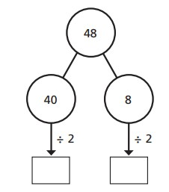

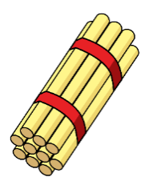
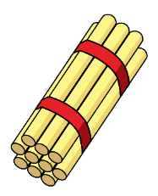
Skill: Divide 2-digits by 1-digit (sharing with no exchange) | Year: 3
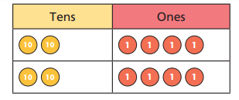  48 ÷ 2 = 24  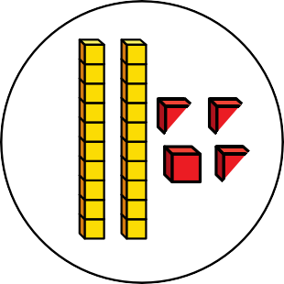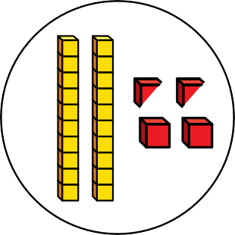 | When dividing larger numbers, children can use manipulatives that allow them to partition into tens and ones.  Straws, Base 10 and place value counters can all be used to share numbers into equal groups.  Part-whole models can provide children with a clear written method that matches the concrete representation.

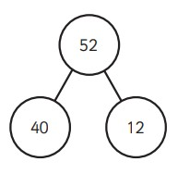
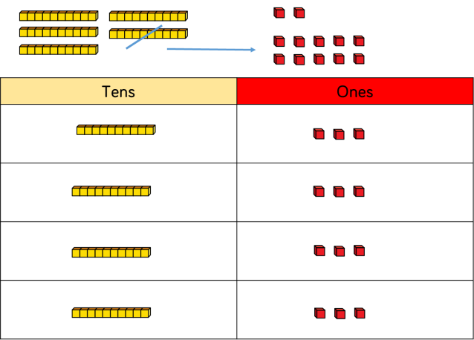
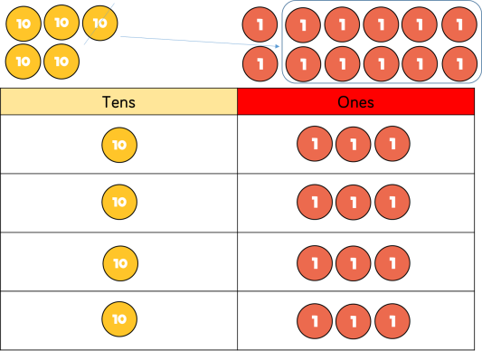

Skill: Divide 2-digits by 1-digit (sharing with exchange) | Year: 3/4
52  ? ? ? ?  52 ÷ 4 = 13  ÷ 4 ÷ 4  10 3  10 + 3 = 13 | When dividing numbers involving an exchange, children can use Base 10 and place value counters to exchange one ten for ten ones.  Children should start with the equipment outside the place value grid before sharing the tens and ones equally between the rows.  Flexible partitioning in a part-whole model supports this method.

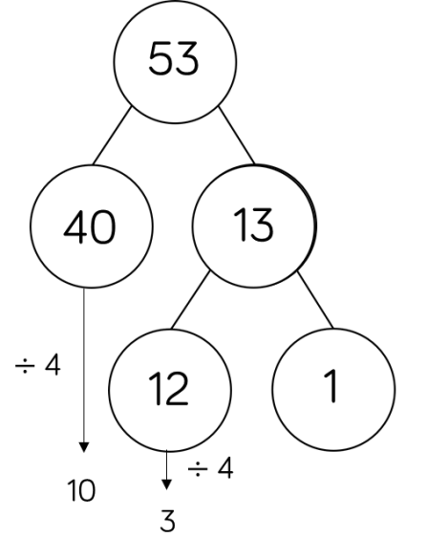
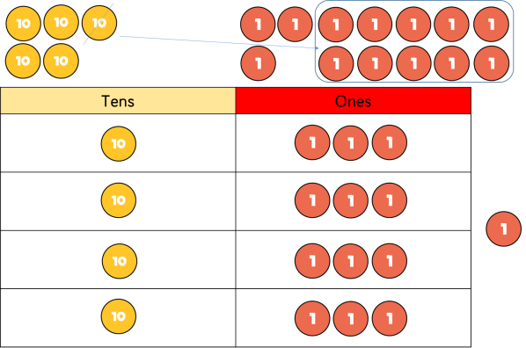

Skill: Divide 2-digits by 1-digit (sharing with remainders) |  |  |  |  | Year: 3/4
 |  |  |  |  | When dividing
 |  | 53 |  |  | numbers with remainders, children can use Base 10 and
13 | 13 | 13 | 13 | 1 | place value counters to exchange one ten
 |  |  |  |  | for ten ones.
 |  |  |  |  | Starting with the
53 ÷ 4 = 13 r1 |  |  |  |  | equipment outside the place value grid will highlight
remainders, as they will be left outside the grid once the equal groups have been made.
Flexible partitioning in a part-whole model supports this method.

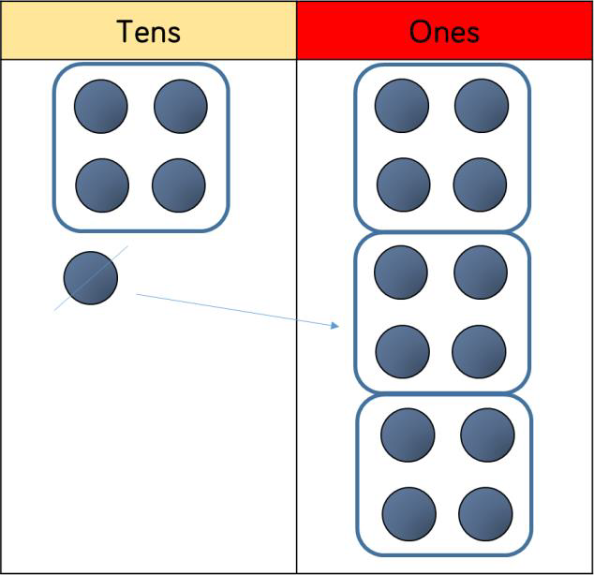
 |  | 1 | 3
 | 4 | 5 | 1 2

Skill: Divide 2-digits by 1-digit (grouping) | Year: 5
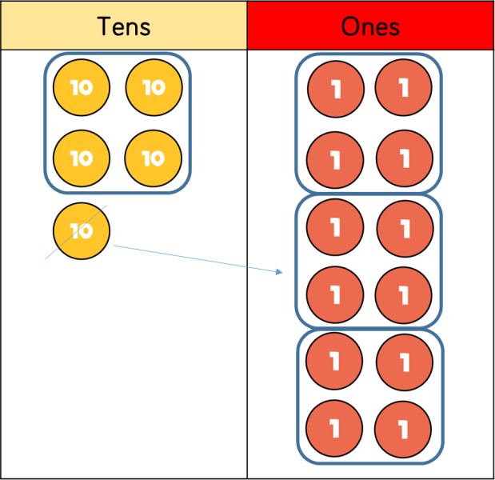  52 ÷ 4 = 13 | When using the short division method, children use grouping. Starting with the largest place value, they group by the divisor.  Language is important here.  Children should  consider ‘How many groups of 4 tens can we make?’ and ‘How many groups of 4  ones can we make?’  Remainders can also be seen as they are left ungrouped.

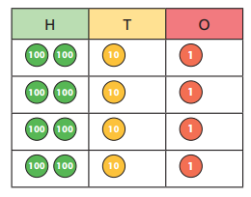
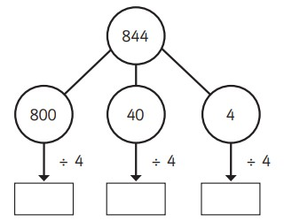
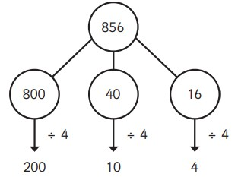
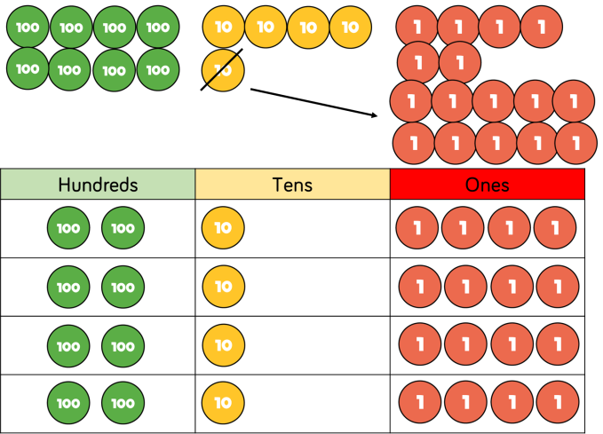
Skill: Divide 3-digits by 1-digit (sharing)

844 ÷ 4 = 211
844

?
?
?
?

856 ÷ 4 = 214

Year: 4

Children can continue to use place value counters to share 3- digit numbers into equal groups.
Children should start with the equipment outside the place value grid before sharing the hundreds, tens and ones equally between the rows.
This method can also help to highlight remainders.
Flexible partitioning in a part-whole model supports this method.

 |  | 2 | 1 | 4
 | 4 | 8 | 5 | 16

Skill: Divide 3-digits by 1-digit (grouping) | Year: 5
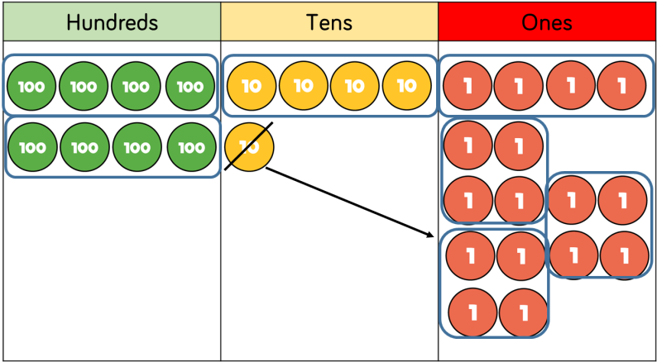  856 ÷ 4 = 214 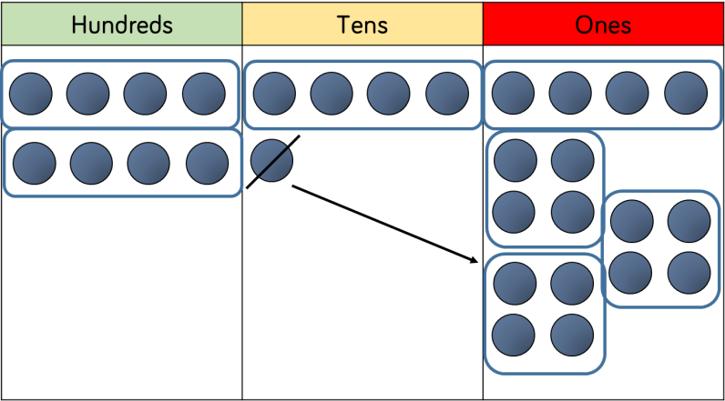 | Children can continue to use grouping to support their understanding of short division when dividing a 3-digit number by a 1-digit number.  Place value counters or plain counters can be used on a place value grid to support this understanding.  Children can also draw their own counters and group them through a more pictorial method.

 | 4 | 2 | 6 | 6
2 | 8 | 5 | 1 3 | 1 2

Skill: Divide 4-digits by 1-digit (grouping) | Year: 5
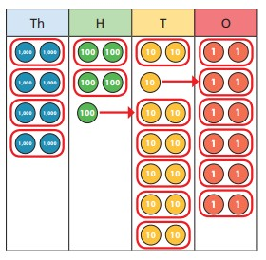  8,532 ÷ 2 = 4,266 | Place value counters or plain counters can be used on a place value grid to support children to divide 4- digits by 1-digit.  Children can also draw their own counters and group them through a more pictorial method.  Children should be encouraged to move away from the concrete and pictorial when dividing numbers with multiple exchanges.

 |  | 0 | 3 | 6
 | 12 | 4 | 4 3 | 7 2

 | 0 | 4 | 8 | 9
15 | 7 | 7 3 | 13  3 | 135

Skill: Divide multi digits by 2-digits (short division) | Year: 6
432 ÷ 12 = 36  7,335 ÷ 15 = 489  15 30 45 60 75 90 105 120 135 150 | When children begin to divide up to 4- digits by 2-digits, written methods become the most accurate as concrete and pictorial representations become less effective. Children can write out multiples to support their calculations with larger remainders.  Children will also solve problems with remainders where the quotient can be rounded as appropriate.

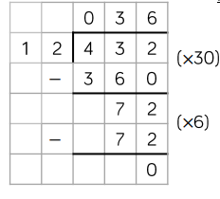
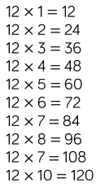
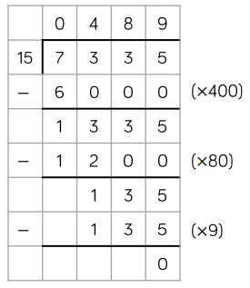
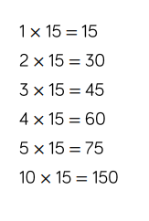
Skill: Divide multi-digits by 2-digits (long division) |  | Year: 6
 |  | Children can also
 |  | divide by 2-digit
 | 432 ÷ 12 = 36 | numbers using long division.
 |  | Children can write out
 |  | multiples to support
 |  | their calculations with
 |  | larger remainders.
 |  | Children will also
 |  | solve problems with
7,335 ÷ 15 = 489 |  | remainders where the  quotient can be
 |  | rounded as
 |  | appropriate.

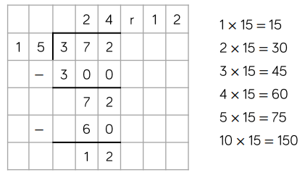
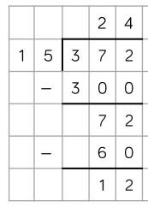
Skill: Divide multi digits by 2-digits (long division) |  | Year: 6
 |  | When a remainder is
 |  | left at the end of a
372 ÷ 15 = 24 r12 |  | calculation, children can either leave it as a remainder or convert
 |  | it to a fraction.
 |  | This will depend on
 |  | the context of the
 |  | question.
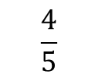 |  | Children can also
 |  | answer questions
 | 372 ÷ 15 = 24 4  5 | where the quotient  needs to be rounded  according to the
 |  | context.

Glossary

Array – An ordered collection of counters, cubes or other item in rows and columns.

Commutative – Numbers can be multiplied
in any order.

Dividend – In division, the number that is divided.

Divisor – In division, the number by which
another is divided.

Exchange – Change a number or expression for another of an equal value.

Factor – A number that multiplies with another to make a product.
Multiplicand – In multiplication, a number to be multiplied by another.

Partitioning – Splitting a number into its
component parts.

Product – The result of multiplying one number by another.

Quotient – The result of a division

Remainder – The amount left over after a division when the divisor is not a factor of the dividend.

Scaling – Enlarging or reducing a number by a given amount, called the scale factor
Total – The aggregate or the sum found by addition.

