Annex B

Bar Model

?

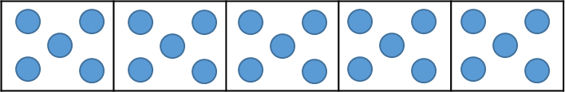
5 × 5 = 25

?

3 × 7 = 21
3 | 3 | 3 | 3 | 3 | 3 | 3

7 × 3 = 21
21
? | ? | ? | ? | ? | ? | ?

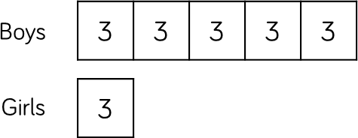
21 ÷ 7 = 3

Children can use the single bar model to represent multiplication as repeated addition. They could use counters, cubes or dots within the bar model to support calculation before moving on to placing digits into the bar model to represent the multiplication.

Division can be represented by showing the total of the bar model and then dividing the bar model into equal groups.

It is important when solving word problems that the bar model represents the problem.

Sometimes, children may look at scaling problems. In this case, more than one bar model is useful to represent this type of problem, e.g. There are 3 girls in a group.
There are 5 times more boys than girls. How many boys are there?
The multiple bar model provides an opportunity to compare the groups.

Number Shapes


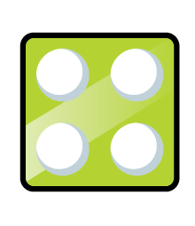
5 × 4 = 20
4 × 5 = 20

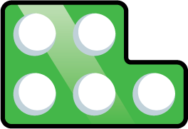
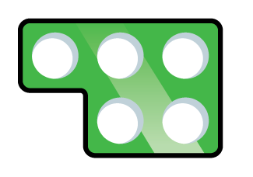
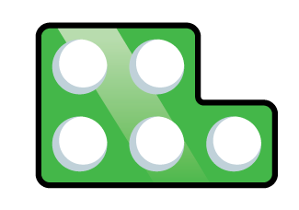
5 × 4 = 20
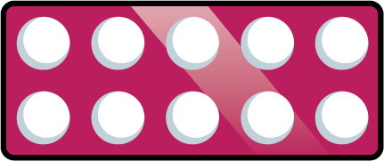
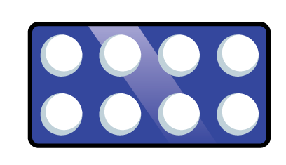
4 × 5 = 20




18 ÷ 3 = 6
Number shapes support children’s understanding of
multiplication as repeated addition.

Children can build multiplications in a row using the number shapes. When using odd numbers, encourage children to interlock the shapes so there are no gaps in the row. They can then use the tens number shapes along with other necessary shapes over the top of the row to check the total. Using the number shapes in multiplication can support children in discovering patterns of multiplication e.g. odd × odd = even, odd × even = odd, even × even = even.

When dividing, number shapes support children’s understanding of division as grouping. Children make the number they are dividing and then place the number shape they are dividing by over the top of the number to find how many groups of the number there are altogether e.g. There are 6 groups of 3 in 18.

Bead Strings

5 × 3 = 15 15 ÷ 3 = 5
3 × 5 = 15

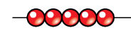
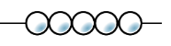

5 × 3 = 15 15 ÷ 5 = 3
3 × 5 = 15

4 × 5 = 20 20 ÷ 4 = 5
5 × 4 = 20
Bead strings to 100 can support children in their understanding of multiplication as repeated addition. Children can build the multiplication using the beads. The colour of beads supports children in seeing how many groups of 10 they have, to calculate the total more efficiently.
Encourage children to count in multiples as they build the
number e.g. 4, 8, 12, 16, 20.

Children can also use the bead string to count forwards and backwards in multiples, moving the beads as they count.

When dividing, children build the number they are dividing and then group the beads into the number they are dividing by e.g. 20 divided by 4 – Make 20 and then group the beads into groups of four. Count how many groups you have made to find the answer.

Number Tracks

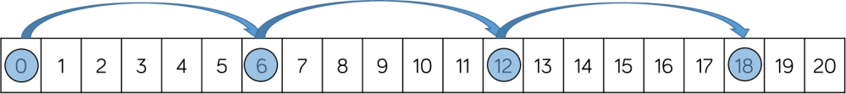

6 × 3 = 18
3 × 6 = 18

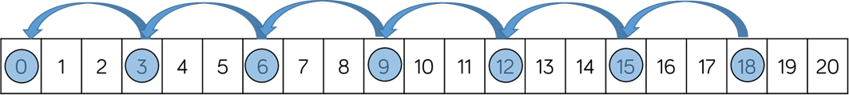

18 ÷ 3 = 6
Number tracks are useful to support children to count in multiples, forwards and backwards. Moving counters or cubes along the number track can support children to keep track of their counting. Translucent counters help children to see the number they have landed on whilst counting.

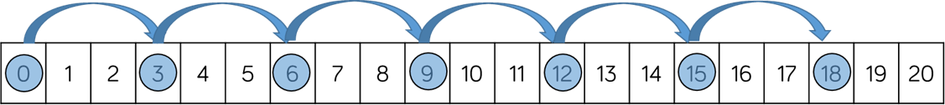
When multiplying, children place their counter on 0 to start and then count on to find the product of the numbers.
When dividing, children place their counter on the number they are dividing and the count back in jumps of the number they are dividing by until they reach 0.
Children record how many jumps they have made to find
the answer to the division.

Number tracks can be useful with smaller multiples but when reaching larger numbers they can become less efficient.

Number Lines (labelled)

4 × 5 = 20
5 × 4 = 20

20 ÷ 4 = 5
Labelled number lines are useful to support children to count in multiples, forwards and backwards as well as calculating single-digit multiplications.

When multiplying, children start at 0 and then count on to find the product of the numbers.
When dividing, start at the number they are dividing and the count back in jumps of the number they are dividing by until they reach 0.
Children record how many jumps they have made to find the answer to the division.

Labelled number lines can be useful with smaller multiples, however they become inefficient as numbers become larger due to the required size of the number line.

Number Lines (blank)

× 4

0 3 6 9 12
A red car travels 3 miles. A blue car 4 times further.
How far does the blue car travel?
× 4
Children can use blank number lines to represent scaling
as multiplication or division.

Blank number lines with intervals can support children to represent scaling accurately. Children can label intervals with multiples to calculate scaling problems.

Blank number lines without intervals can also be used for
children to represent scaling.

0 3 12
A blue car travels 12 miles.
A red car 4 times less.
How far does the red car travel?

Base 10/Dienes (multiplication)

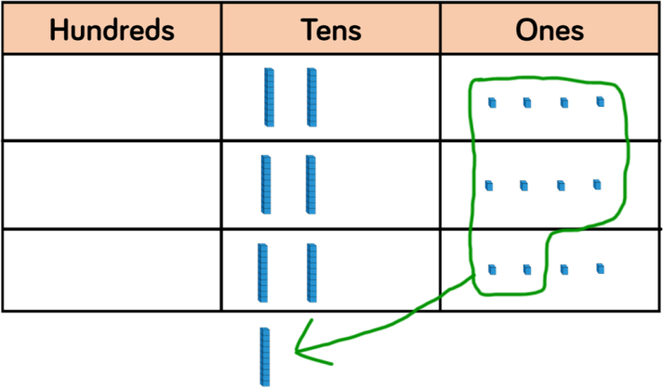
Using Base 10 or Dienes is an effective way to support
24
children’s understanding of column multiplication. It is
× 3 important that children write out their calculation alongside the equipment so they can see how the
72 concrete and written representations match.
1 As numbers become larger in multiplication or the amounts of groups becomes higher, Base 10 / Dienes becomes less efficient due to the amount of equipment and number of exchanges needed.

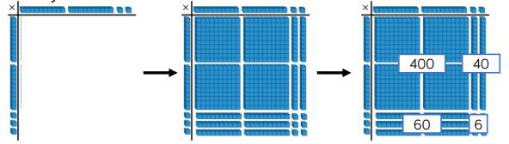
Base 10 also supports the area model of multiplication well. Children use the equipment to build the number in a rectangular shape which they then find the area of by calculating the total value of the pieces This area model can be linked to the grid method or the formal column method of multiplying 2-digits by 2-digits.

Base 10/Dienes (division)

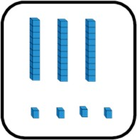
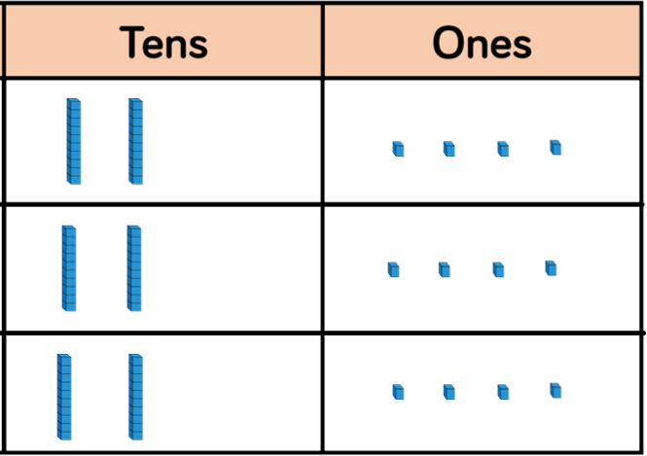
68 ÷ 2 = 34

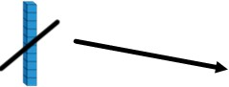
72 ÷ 3 = 24
Using Base 10 or Dienes is an effective way to support
children’s understanding of division.

When numbers become larger, it can be an effective way to move children from representing numbers as ones towards representing them as tens and ones in order to divide. Children can then share the Base 10/ Dienes between different groups e.g. by drawing circles or by rows on a place value grid.

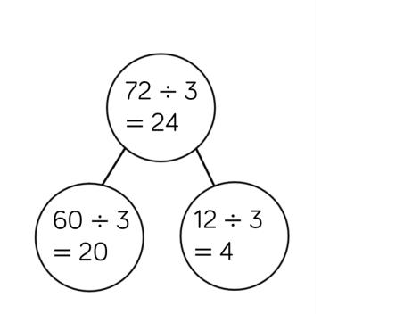
When they are sharing, children start with the larger place value and work from left to right. If there are any left in a column, they exchange e.g. one ten for ten ones. When recording, encourage children to use the part- whole model so they can consider how the number has been partitioned in order to divide. This will support them with mental methods.

Place Value Counters (multiplication)

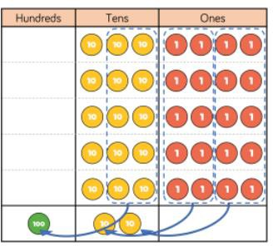
34 Using place value counters is an effective way to support
children’s understanding of column multiplication. It is
5
× important that children write out their calculation

170

1 2

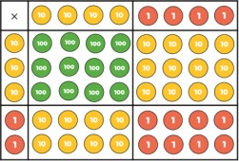
44
× 32

8
80
120
alongside the equipment so they can see how the concrete and written match.

As numbers become larger in multiplication or the amounts of groups becomes higher, Base 10 / Dienes becomes less efficient due to the amount of equipment and number of exchanges needed The counters should be used to support the understanding of the written method rather than support the arithmetic.

Place value counters also support the area model of multiplication well. Children can see how to multiply 2- digit numbers by 2-digit numbers.

+ 1200
1408
1

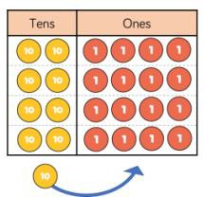
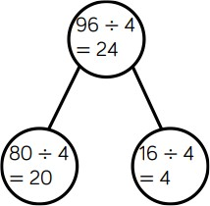
Place Value Counters (division)

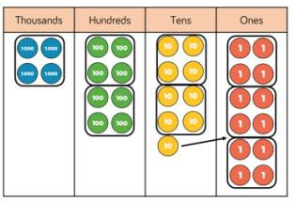
1223
48912
4
Using place value counters is an effective way to support
children’s understanding of division.

When working with smaller numbers, children can use place value counters to share between groups. They start by sharing the larger place value column and work from left to right. If there are any counters left over once they have been shared, they exchange the counter e.g. exchange one ten for ten ones. This method can be linked to the part-whole model to support children to show their thinking.

Place value counters also support children’s understanding of short division by grouping the counters rather than sharing them. Children work from left to right through the place value columns and group the counters in the number they are dividing by. If there are any counters left over after they have been grouped, they exchange the counter e.g. exchange one hundred for ten tens.

