Our Curriculum Timetable Overviews 2022- 2023
Spring 2023
Reception
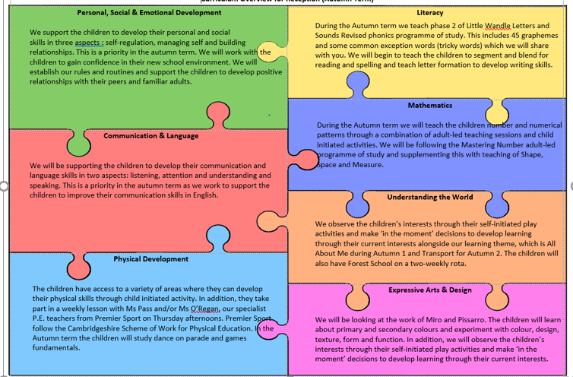
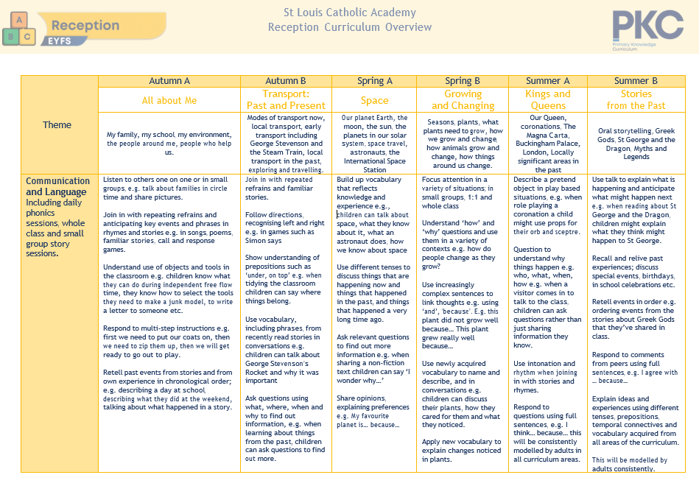
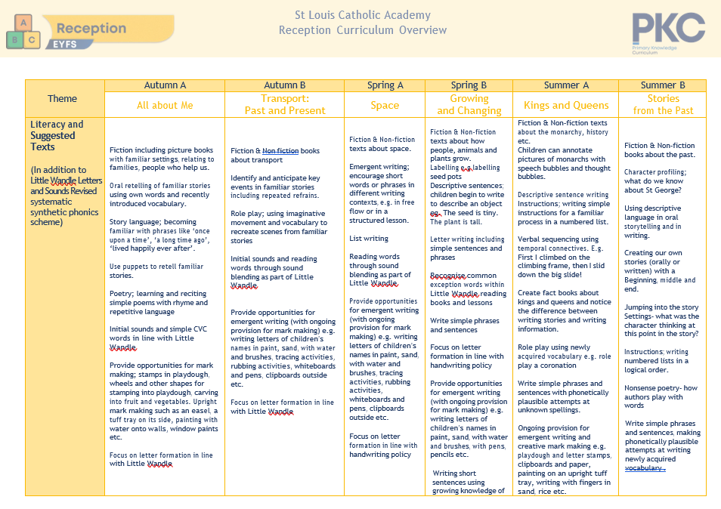
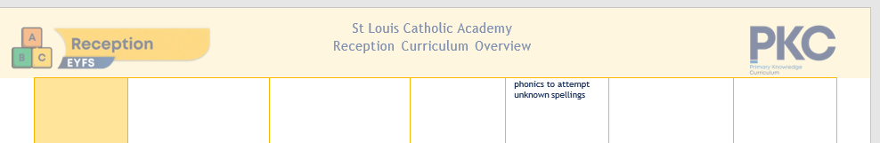
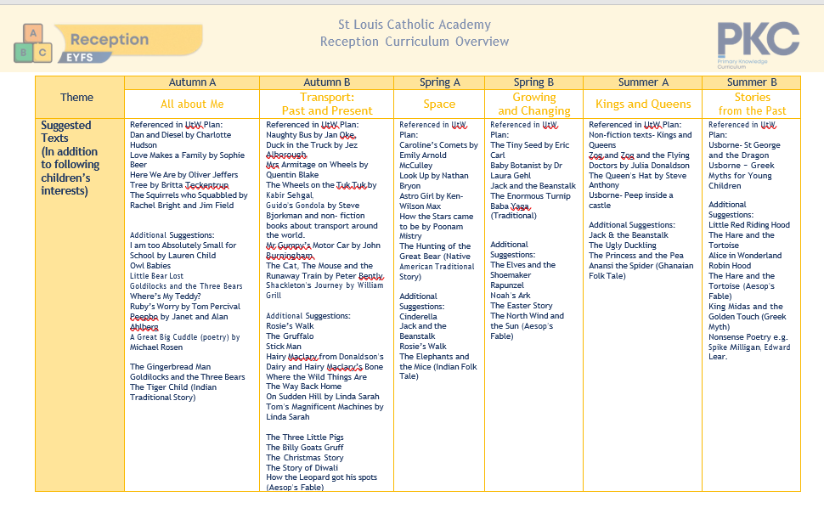
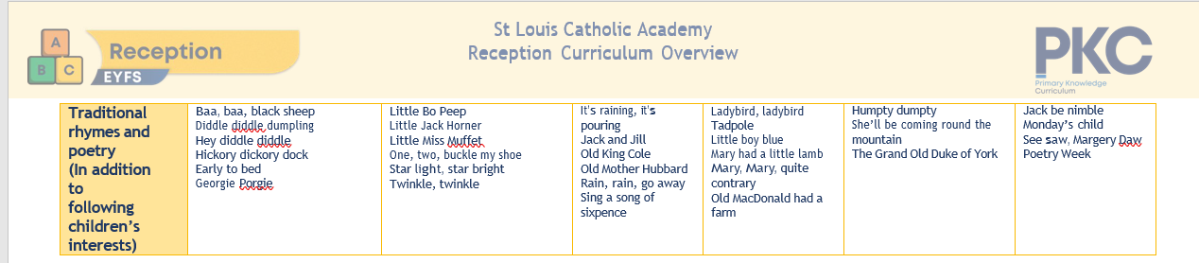

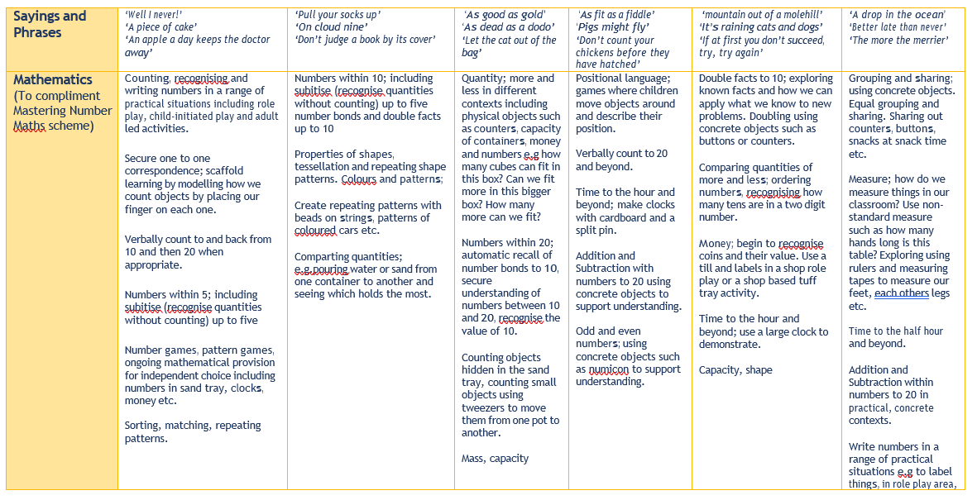

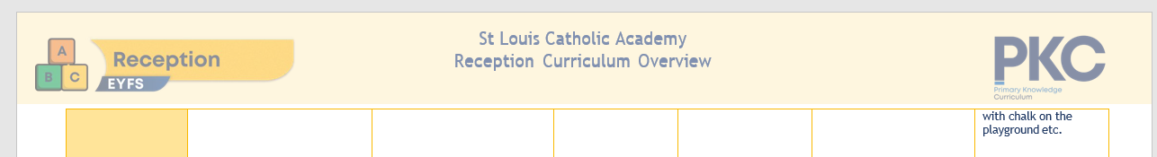
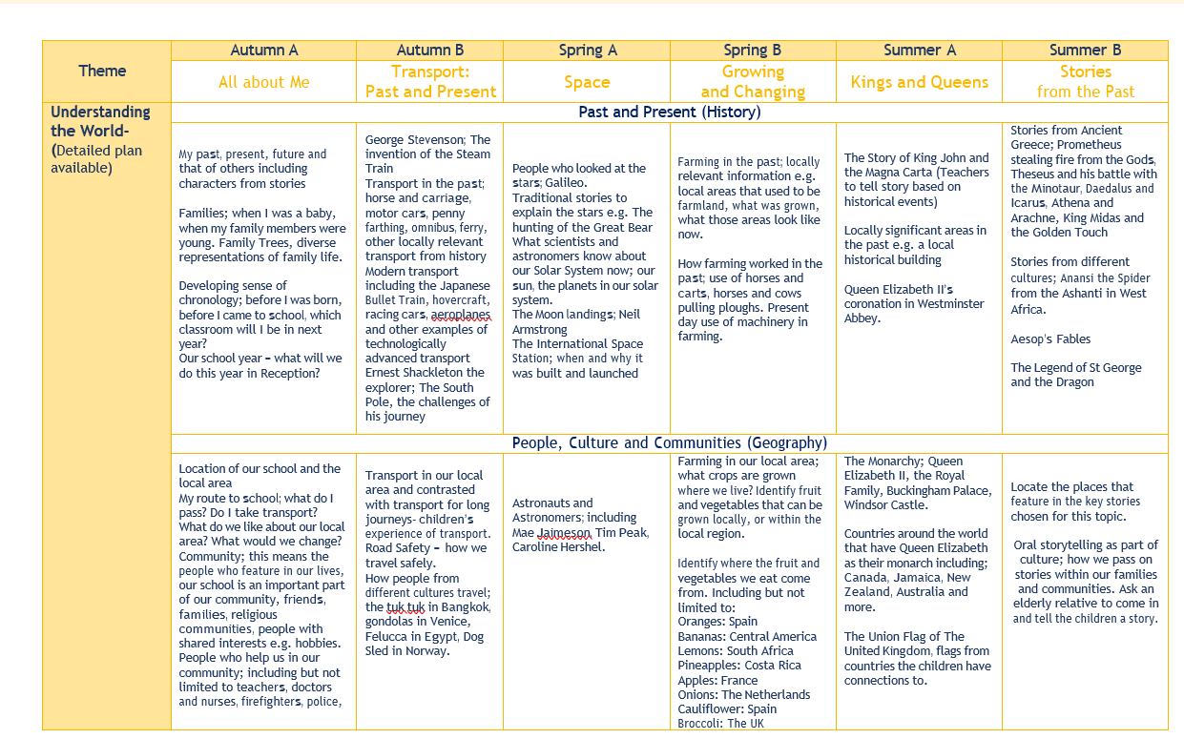
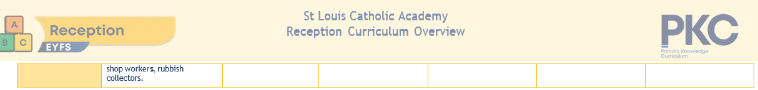
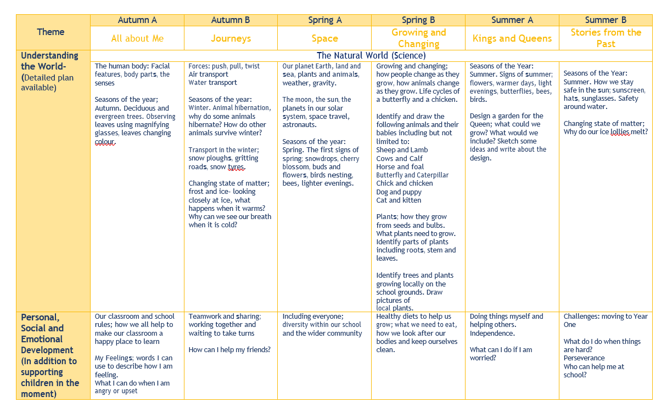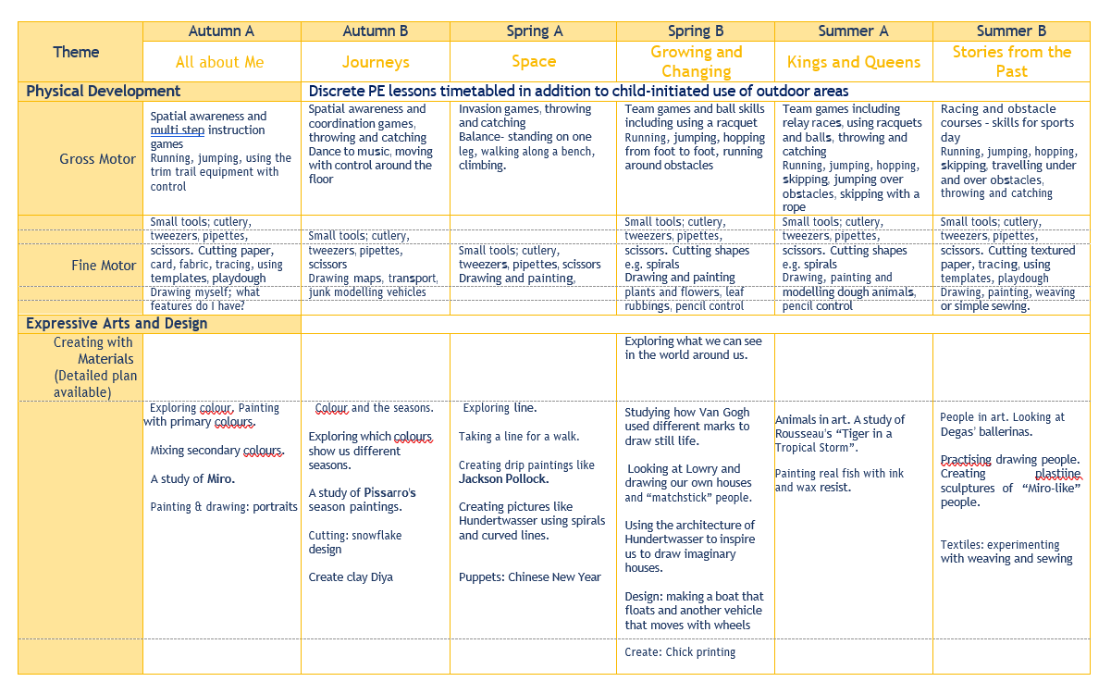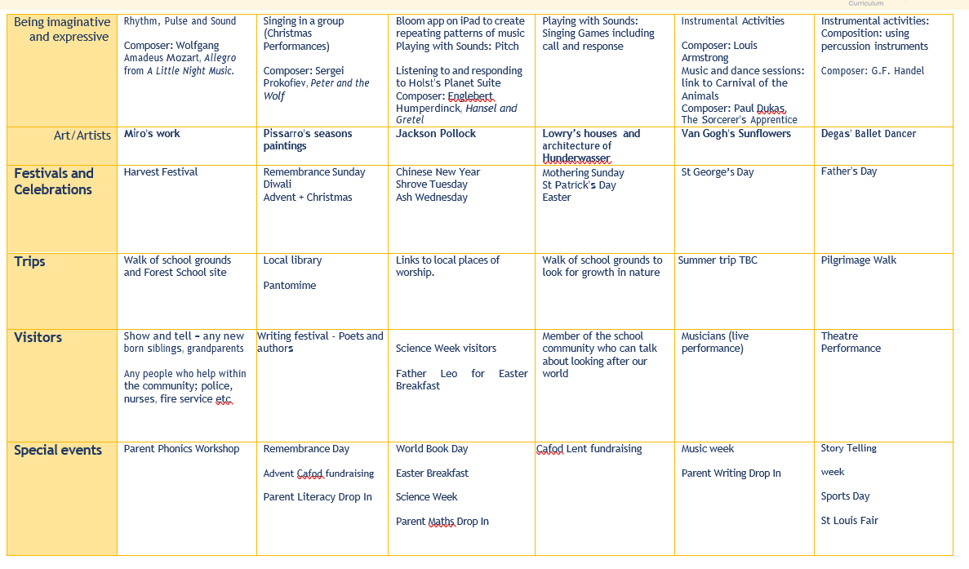
KS1 Spring 2022 2023
SPRING 1 (5 ½ WEEKS)
RE | Families and Celebrations  Children will learn about Jesus’s Presentation in the Temple and start to discuss why this was important to the Holy Family and then link this to Baptism. They will learn about what it means to belong to a family, including the school family etc. and why celebrations are an important part of life. |  |  | Prayer  The children will learn about different ways of praying and reflecting on life. Within the Catholic tradition, this will include praise, thanksgiving, petition and saying sorry as well as the signs and symbols used in prayer. They will also learn more about the prayers of the Mass and have the opportunity to reflect on their own daily words and actions.
Reading | Year 1 have their 3 times a week Little Wandle Reading Groups focusing on fluency, prosody and comprehension skills. These reading books come home at the weekend for you to continue this practice and for them to show you everything they’ve learnt that week! Please continue to enjoy your sharing books during the week and remember to change them in school before their LW book comes home.
 | Year 1 (Writing Week) | Year 1: The Tale of Peter Rabbit  Key skills foci:  To know what a biography is and connect the cause and effect in stories | Year 1 (Writing Week) | Year 1: The Tale of Peter Rabbit  Key skills foci:  To sequence events in chronological order and discuss moral issues. | Year 1 (Writing Week) | Year 1: Look Up!  Key skills foci:  To be able to use clue words to answer questions and extract lessons learnt by different characters.
 | Year 2: The Quangle Wangle’s Hat (poetry).  Key skills foci:  Summarising, retrieving, using description for inference |  | Year 2: Coming to England.  Key skills foci:  Prediction based on the text, retrieval and personal response |  | Year 2: The Goose That Laid A Golden Egg.  Key Skills foci:  Retrieval, sequencing, synonyms, evidence in support of inference
Phonics (Y1) | /ee/ e-e these  /oo/ /yoo/ ew chew new  /ee/ ie shield  /or/ aw claw | Grow the code:  /igh/ ie i i-e  /ai/ ay a a-e  /oa/ oa o o-e  /ee/ e ie e-e ea  /oo/ /yoo/ ew u-e u ue | Grow the code:  /ee/ y funny  /e/ ea head  /w/ wh wheel  /oa/ oe ou toe shoulder | Grow the code:  /igh/ y fly  /oa/ ow snow  /j/ g giant  /f/ ph phone | Grow the code:  /l/ le al apple metal  /s/ c ice  /v/ ve give | Grow the code:  /u/ o-e o ou some mother young  /z/ se cheese  /s/ se ce mouse fence  /ee/ ey donkey
Writing | Year 1: Calligrams.  Key skills foci:  To explain why a poem is presented in a specific way and to use a model to create a poem. | Year 1 (Reading Week) | Year 1: Recount from Personal Experience.  Key skills foci:  To be able to explain events chronologically and to write simple sentences to explain an event. | Year 1 (Reading Week) | Year 1: Informal Letters.  Key skills foci:  To understand the features and layout of an informal letter, to organise ideas in a letter, to use a question mark accurately and to use the personal pronoun I accurately. | Year 1 (Reading Week)
 | Year 2: Poetry on a Theme.  Key skills foci:  To make connections between poems and prepare and perform a humorous poem. | Year 2: Non-Chronological Report.  Key skills foci:  Maintaining the present tense, using simple subordinating conjunctions, writing to inform |  |  | Year 2: Formal Invitations.  Key skills foci:  Using statements and commands, organising information in an ways to understand way
Maths | Year 1: Place Value within 20:  Key Steps:  Counting within 20, understanding 11-20, 1 more and 1 less, using and estimating on a number line to 20, comparing and ordering numbers to 20. |  |  | Year 1: Addition and Subtraction within 20:  Key Steps:  Adding by counting within 20, add ones using number bonds, find and make number bonds to 20, doubles, near doubles, subtract ones using number bonds, subtraction – counting back, subtraction – finding the difference, missing number problems
 | Year 2: Money  Key Steps:  Counting money in pence, counting money in pounds (coins and notes), choosing notes and coins, making the same amount, comparing amounts of money, calculating with money, making a pound. |  | Year 2: Multiplication & Division  Key Steps:  Recognising, making and adding equal groups; introducing the concept of multiplication including arrays and number sentences; making equal groups through grouping and sharing; doubling and halving; odd and even numbers; multiplying and dividing by 2, 5 and 10.
Science | Seasons and Weather
 | To name and describe the four seasons. | To know that tools are used to gather information about the weather. | To present data using a graph. | To know that there are different types of clouds. | To understand that weather forecasts help people to prepare for different kinds of weather. | To understand that certain kinds of weather can be dangerous.
Humanties | Geography Unit: The UK
 | To understand that the UK is a union of 4 countries. | Scotland:  the landscape, climate, culture and traditions. | Wales:  The landscape (including mountains and valleys and how this affects building), the climate and the flag. | Northern Ireland:  Ireland as an island, the location of key cities and Giant’s Causeway. | England:  The flag, the location of our school, rural and urban differences and the coastline. | Quiz!
PE | Premier Sport: Gym
 | Class Teacher: Dance
Art | Architecture
 | To understand that architecture is the art of designing buildings. | To understand that buildings are built for a purpose. | To be able to describe different features of buildings. | To be able to describe different features of Southwark Cathedral. | To design a building with a purpose. | To show what I know about architecture.
RSE / PSHCE | Ten: Ten Module 1, Units 3 & 4
 | Feelings, likes and dislikes | Feeling inside out – different feelings at different times | Super Susie gets angry – discussing strong feelings | The Life Cycle:  from a baby to an elderly person | A Time for Everything:  optional unit on bereavement | TBC

SPRING 2 (6 WEEKS)
RE | Giving - Lent  Palm Sunday, the Last Supper, Judas’s betrayal of Jesus, who was Pontius Pilate, the death of Jesus… moving onto the Resurrection when we return after Easter.
Reading | Year 1 have their 3 times a week Little Wandle Reading Groups focusing on fluency, prosody and comprehension skills. These reading books come home at the weekend for you to continue this practice and for them to show you everything they’ve learnt that week! Please continue to enjoy your sharing books during the week and remember to change them in school before their LW book comes home.
 | Year 1 (Writing Week) | Year 1: Here We Are Notes for Living on Planet Earth (1).  Key skills foci:  To know what sub-headings are and that actions are performed for a reason. | Year 1 (Writing Week) | Year 1: Here We Are Notes for Living on Planet Earth (2).  Key skills foci:  To understand how colours can create a mood and understanding what an author’s purpose is. | Year 1 (Writing Week) | Year 1: Chocolate Cake (MR).  Key skills foci:  To understand how sub-headings are used and that actions are performed for a reason.
 | Year 2: The Rhythm of the Rain.  Key skills foci:  Retrieving information from illustrations, inferring the mood from a section of text. |  | Year 2: Little People, Big Dreams: David Attenborough.  Key skills foci:  To be able to retrieve specific information from a text and sequence events chronologically. |  | Year 2: Flexible Weeks.
Phonics (Y1) | Grow the code:  /oo/ u ew ue u-e ui ou oo fruit soup  /ee/ ea e e-e ie ey y ee  /s/ c se ce ss  /z/ se s zz  /oa/ ow oe ou o-e o oa | Consolidation Week | /ur/ or word  /oo/ u oul awful would  /air/ are share  /or/ au aur oor al author dinosaur floor walk | /ch/ tch match  /ch/ ture adventure  /ar/ al half  /ar/ a father | /or/ a water  Schwa in longer words: different  /o/ a want  /air/ ear ere bear there | /ur/ ear learn  /r/ wr wrist  /s/ st sc whistle science  Schwa at the ends of words: actor
Writing | Year 1: Poetry on a Theme (Nature).  Key skills foci:  To know that a theme is the main idea of a poem and to talk about the language in a poem. To write in a similar style. | Year 1 (Reading Week) | Year 1: Stories with Familiar Settings.  Key skills foci:  To identify the main components of a story, to sequence sentences for a story and to use adjectives to describe a setting. | Year 1 (Reading Week) | Year 1: Recount from Personal Experience.  Key skills foci:  To know that a recount follows a chronological order, to recount an event orally and to say sentences aloud before recording. | Year 1 (Reading Week)
 | Year 2: Stories from Other Cultures.  Key skills foci:  To include culture specific details, to write in the past tense and to write in the third person. |  | Year 2: Recount from Personal Experience.  Key skills foci:  To write in the first person, to write in the past tense and to recount a real event or experience. |  | Year 2: Flexible Weeks.
Maths | Year 1: Place Value within 50:  Key Steps:  Counting from 20-50, counting by making groups of 10s, groups of 10s and 1s, partition into 10s and 1s, the number line to 50, estimating on a number line to 50, 1 more/1 less |  |  | Year 1: Length and Height:  Key Steps:  Comparing lengths and heights, measuring length using objects, measuring length in cm
 | Year 2: finishing multiplication and division | Year 2: Length & Height  Key Steps:  Measure in cm, measure in m, compare lengths and heights, order lengths and heights, four operations with lengths and heights |  | Year 2: Mass, Capacity & Temperature.  Key Steps:  Comparing mass, measuring in grams and kg, using the four operations with mass, comparing volume and capacity, measuring in ml and l, using the four operations with volume and capacity and exploring temperature.
Science | Taking Care of the Earth
 | To describe different ways that we can take care of the Earth. | To know that there are natural and manufactured resources that people on Earth use. | To identify logging as a way of harvesting the Earth’s natural resources. | To know that people create pollution which can harm the environment. | To know that recycling means turning used things into something new. | Quiz!
Humanties | History: Kings, Queens and Leaders
 | To know that the UK has been ruled by kings and queens for many years. | To understand that King John I made an important promise to the people of England. | I know that a parliament was set up to make decisions for the country. | To understand that King Charles I did not want to listen to Parliament. | To know that there was a time when England did not have a king. | Quiz!
PE | Premier Sport: Gym
 | Class Teacher: Dance
Art | Style in Art: Narrative Art
 | To understand that artists can use different styles. | To know that Van Gogh painted in different styles. | To know that Van Gogh used short brush strokes in Starry Night. | To understand that art can tell a story. | To explore how characters are represented in art. | -
RSE / PSHCE | Ten: Ten Module 2, Units 1 & 2
 | God loves you – the story of the prodigal son | Special people in our lives; trust | Treating others well | Saying sorry | TBC | TBC

LKS2 Spring Curriculum 2022-23
Spring 1
English - Writing | Persuasive Adverts  Children will learn:  How superlatives are formed  What a slogan is used for  The purpose of a rhetorical question  Presentational devices to use in an advert  Use appropriate presentation and language to write a persuasive advert | Explanatory  Children will learn:  A range of descriptive devices  First person perspective  How to use coordinating conjunctions  Describe a setting in detail  Build atmosphere through precise selection of vocabulary | Consolidation
Reading Year 3 | Sam Wu is Not Afraid of the Dark  Focus on the core text for comparing, predicting, summarising, understanding themes, authorial intent and a personal response
Reading Year 4 | Young Gifted and Black  Focus on the core text for comparing, predicting, summarising, understanding themes, authorial intent and a personal response
Maths Year 3 | Multiplication and Division B  Multiples of 10  Reasoning about multiplication  Multiply a 2-digit number by a 1-digit number  Link multiplication and division  Divide a 2-digit number by a 1-digit number  Scaling | Length and Perimeter  Measure in metres, centimetres and millimetres  Equivalent lengths (metres and centimetres)  Equivalent lengths (centimetres and millimetres)  Compare lengths  Add and subtract lengths  Measure and calculate perimeter
Maths Year 4 | Multiplication and Division B  Factor pairs  Multiply and divide by 10 and 100  Informal written methods for multiplication  Multiply a 2-digit number by a 1-digit number  Multiply a 3-digit number by a 1-digit number  Divide a 2-digit number by a 1-digit number  Divide a 3-digit number by a 1-digit number | Length and Perimeter  Measure in kilometres and metres Equivalent lengths (kilometres and metres) Perimeter of a rectangle  Perimeter of rectilinear shapes  Find missing lengths in rectilinear shapes Calculate perimeter of rectilinear shapes Perimeter of regular polygons | Fractions  Understand the whole  Count beyond 1 Partition a mixed number  Number lines with mixed numbers

RE | Jesus the Teacher  In this topic the children will learn that Jesus was a teacher who came to show us how to live. They will explore Jesus’ early life and learn about his presentation in the Temple. The children will know that Jesus used parables in his teaching and reflect on the meaning of the Parable of the Sower and Unforgiving Servant.
Science | Cycles in Nature  They will study patterns, trends and cycles that occur throughout the seasons, in the life of plants and in the life of animals. Children will understand that the tilt of the earth creates our seasons. Children will ask and answer questions about the patterns seen in nature as the seasons change. They will look closely and observe changes in the seasons in their own environment. Children will think scientifically about the changes to plants through the seasons, how the increased hours of sunshine in the summer help plants to gain the necessary energy to grow bigger.
History | The Anglo-Saxons, Scots and Vikings  The children begin the unit recapping what they have learned so far about the Romans in Britain. They learn that after the Romans left, a mix of tribes from Germany, Denmark and the Netherlands began to migrate to England. The three biggest tribes were the Angles, the Saxons and the Jutes. This group of people are known today as the Anglo Saxons. This unit builds on the children’s understanding of the substantive concepts of migration, invasion, settlement, religion and monarchy. The children will learn about the lives of people who lived in this period- how they lived, their homes, their jobs, what they ate and what they did for fun. They will discuss how we know about the lives of people who lived so long ago, and learn about primary and secondary sources such as artefacts found at Sutton Hoo, places such as West Stow and the Anglo-Saxon Chronicle. They will also look at religious beliefs of both the Anglo Saxons and the Vikings, and how both were gradually converted from their Pagan beliefs to Christianity. They will learn about the monk and scholar, Bede the Venerable, who wrote a book about the English people and the church.
Geography | Rivers  In this unit children will develop their understanding of how people interact with the world around them. They will explore how people use rivers, for example for irrigation for farmland, for transport and as a water supply. They will consider the impact of less than normal rainfall on rivers, specifically the Mississippi River, and then in turn the impact that a drought can have on the people who rely on the river. As the National Curriculum requires, children will be using maps, atlases, globes and digital/computer mapping to locate the rivers, the countries they journey through and to describe their features, particularly their shape and direction of travel.
PE | Invasion games and Gym
ICT | Writing for different audiences  (Purple Mash 4.4)
Art | Art of Ancient Egypt  They learn that the art of ancient Egypt includes sculpture, paintings on papyrus and walls as well as buildings. Much of the art that we have from ancient Egypt is from tombs and the children learn that the artwork that remains shows us not only about what the ancient civilisation believed about the afterlife but also about how they lived, how they were ruled and the power of the pharaohs. The children study in detail the Great Sphinx of Giza, the bust of Nefertiti and the representation of Egyptian gods and goddesses. They create their own sphinx from clay, use mixed media to make Egyptian collars and draw Egyptian gods and goddesses in profile on their own homemade papyrus.

Spring 2
English - Writing | Poetry on a Theme (Emotions)  Children will learn:  How to form and use: • alliteration • rhyme • assonance Prepare and perform narrative poems Make connections between poems Select precise and ambitious vocabulary  Write a poem on a theme | Non-Chronological Reports (B)  Children will learn:  The structure and tone of a nonchronological report  How to use paragraphs to organise information  Use a variety of sentence structures  Select and use precise and formal vocabulary | Stories from other cultures (B)  Children will learn:  How to form the past tense  The third person perspective  Editing strategies  Use a range of descriptive devices to compose and recount a short narrative  Use cultural references to indicate a setting | Consolidation
Reading Year 3 | Operation Gadget Man  Focus on the core text for comparing, predicting, summarising, understanding themes, authorial intent and a personal response
Reading Year 4 | Wind in the Willows  Focus on the core text for comparing, predicting, summarising, understanding themes, authorial intent and a personal response
Maths Year 3 | Fractions A  Understand the denominators of unit fractions  Compare and order unit fractions  Understand the numerators of non-unit fractions  Compare and order non-unit fractions  Fractions and scales  Fractions on a number line and count in fractions  Equivalent fractions on a number and as bar models |  | Mass and Capacity  Use scales  Measure mass in grams and kilograms Equivalent masses (kilograms and grams) Compare mass  Add and subtract mass  Measure capacity and volume in millilitres and litres  Equivalent capacities and volumes (litres and millilitres)  Compare capacity and volume  Add and subtract capacity and volume
Maths Year 4 | Fractions  Compare and order mixed numbers  Convert mixed numbers to improper fractions  Convert improper fractions to mixed numbers  Equivalent fractions on a number line  Add two or more fractions  Add fractions and mixed numbers  Subtract two fractions  Subtract from whole amounts and subtract from mixed numbers |  | Decimals A  Tenths as fractions and as decimals  Tenths on a place value chart and on a number line  Divide a 1-digit number by 10  Divide a 2-digit number by 10  Hundredths as fractions and as decimals  Hundredths on a place value chart  Divide a 1- or 2-digit number by 100
RE | Jesus the Saviour  In this topic the children will learn that Jesus came from God to share our life so that we can share in the life of Jesus. They will reflect on how Jesus is like us and how he is like God. They will consider ways in which they can share in the life of Jesus. They will learn about the events of Holy Week, particularly Palm Sunday, Holy Thursday, Good Friday and Easter Sunday.
Science | Plants  In this unit, pupils will look more closely at flowering plants, their features and the functions of their features. They will look at specific species including hydrangea and cacti and there is scope for including flowering plants that grow in the local area if relevant. Pupils will learn that the scientific study of plants is called botany and that what we understand about plants comes from contributions from many botanists over the years (disciplinary knowledge). This unit also covers pollination and seed dispersal, two vital parts of the life cycle of a plant. There is an emphasis on interconnection in these lessons, pupils learn how animals such as bees are vital for the pollination process and also, in some instances, for seed dispersal.
History | The Anglo-Saxons, Scots and Vikings  In this unit, the children will also learn about the Picts and the Scots. They will discuss how historians find out about these people in the past, and how they engage in historical debate, such as what the symbols on Pictish Stones can tell us. During this unit, the children will learn about the Vikings and the significance of Viking Long ships that enabled them to travel, trade, raid and invade! They will look at the relationship between the Anglo Saxons and the Vikings; the battles and the compromises that took place during this period. They will learn about the lives of significant people during this period such as Alfred the Great, Kind Cnut and Edward the Confessor. This unit ends with the Battle of Hastings in 1066.
Geography | UK Geography: The South West  This unit will focus on the following aspects of the geography of the South West; coastal areas and erosion, landmarks and tourism, agriculture and climate, change over time. Children will begin by locating the region, looking at its climate and the effect the Gulf Stream has. They will locate National Parks and areas of Outstanding Natural Beauty on a map of the South West. Children will learn the importance of the Jurassic Coastline that runs along the coastline from Devon through to Dorset. They will learn that coastal erosion reveals fossils in the rocks that help scientists to understand what the region was like many millions of years ago. They will look at how coastal erosion has shaped the land creating features such as Durdle Door; a natural limestone arch in Dorset. Children will study landmarks and tourism in the South West, including Stonehenge, Glastonbury Tor, Durdle Door, Bath, Bournemouth, and The Eden Project. They will understand that tourism is an important industry in the South West. Children will learn about agriculture in the South West and find out what the farming industry produces.
PE | Invasion games and Gym
ICT | Logo  (Purple Mash 4.5)
Art | Anglo Saxon Art  Children study art of the Anglo Saxons by focusing on objects found at the burial ground at Sutton Hoo, illuminated letters painted in the Lindisfarne Gospels and the Bayeux tapestry. They learn that the interlocking and interlaced patterns used in the metalwork at Sutton Hoo are echoed in the designs used in the Lindisfarne Gospels, and use watercolours to produce their own, similar designs. The unit concludes by looking at the Bayeux tapestry, produced at the end of the Anglo-Saxon era and allows the children to explore how art can tell a story, rather like an old-fashioned comic strip. They finish the unit by creating a collaged boat, using textiles, in the style of the Bayeux tapestry.

UKS2 2022 2023 Spring

UKS2 Spring Curriculum 2022-23
Spring 1
English - Writing | Discursive Writing and Speeches  The children will learn that the passive voice conveys a formal tone and that multiple viewpoints need to be represented in a discussion.  They will edit their writing against specific criteria and deliver a speech using appropriate formality and expression. | Formal letters of Application  During this unit the children will use the subjunctive to formally make a request or suggest a possibility and look at how language can be adapted to persuade.  They will use and sustain a formal tone and structure a formal letter in clear paragraphs |  | Poems which explore form  The children will learn what word play is and why poets use it. They will look at the structure of different types of poems and construct a poetry collection on a theme. They will experiment with vocabulary. | Consolidation
Reading Year 5 | A Midsummer Night’s Dream  Focus on the core text for comparing, predicting, summarising, understanding themes, authorial intent and a personal response | I am not a label  Focus on the core text for comparing, predicting, summarising, understanding themes, authorial intent and a personal response
Reading Year 6 | Rooftoppers  Focus on the core text for comparing, predicting, summarising, understanding themes, authorial intent and a personal response
Maths Year 5 | Multiplication and Division B  Multiplying by 1-digit and 2-digits  Division with remainders  Solving multiplication and division problems |  | Fractions B  Multiplying fractions  Finding fractions of amounts |  | Consolidation
Maths Year 6 | Ratio  Ratio language and symbol  Scale drawing and factors  Ratio and proportion problems | Algebra  Function machines  Form expressions and equations  Solve equations  Solve problems |  | Decimals  Round, add and subtract decimals  Multiply and divide by 10, 100 and 1000  Multiply and divide decimals
RE | Jesus – Bread of Life  In this topic the children will learn about the different parts of the Mass, particularly the Liturgy of the Word and the Liturgy of the Eucharist. They will learn about the first Passover and show an understanding of the links between it and the Last Supper Jesus had with his disciples. They will reflect on the importance of the body and blood of Christ for Catholics.
Science | Reproduction  This unit begins with a practical task to set up an investigation into asexual reproduction in plants. Pupils will observe a potato, ginger and garlic over the course of this unit to look for growth. Pupils will learn that some plants reproduce asexually, not requiring a male and female, but reproducing by copying itself. Moving on to reproduction in animals, pupils will look again at how animals reproduce, building on their knowledge from previous years. They will learn about internal and external fertilisation and will understand that different animals reproduce in different ways. Pupils will build on this knowledge and look at growth stages of animals. Pupils will learn that animals care for their young in different ways and that offspring vary hugely in their ability to be independent when they are born.
History | The Industrial Revolution  This unit builds on chronologically from children’s knowledge of both the French Revolution and the Transatlantic Slave Trade. During the Slave Trade unit, the children learned about how Britain imported and exported goods at this time. During this unit, the children will look at the similarities and differences between the impact that the Industrial Revolution had on the lives of the rich and the poor. The children will not only learn about the economic and technological benefits of the Industrial Revolution but will also explore the social context, with a focus on how life changed for those who began working in factories during this time. The unit will also discuss the lives of significant people who had an influential national (and even global) impact, such as Richard Arkwright, James Watt and George Stephenson.
Geography | British Geography: East Anglia, Midlands, Yorkshire, Humberside  This unit builds on the previous units and looks more closely at East Anglia, the Midlands, Yorkshire and Humberside. Studying these regions of the UK will show children the differences in both industry and landscape within England. Children will use relief maps to find out about the landscape of each region. They will learn that East Anglia is largely flat and that the land there is used for growing crops. They will learn that topography looks at the shape of land and what is on the surface of the land. They will use a topographic map to look at a region of The Fens and will be able to identify which areas are below sea level and what this means for people living in the area.  When studying the Midlands, children will identify key places in the region, including Birmingham, and will look at how the industry of the Midlands has changed. They will identify the Grand Union Canal and will understand its importance for regional trade in the past. Building on this regional knowledge, children will then look at Yorkshire and will contrast relief maps of the region with their knowledge of the Fens. Children will study the geographical features of the local areas, recognising valleys and looking at images of the Yorkshire Dales.
PE | Netball and Gym
ICT | Data Bases  (Purple Mash 5.4)
Art | Art from Western Africa  This unit explores the art of Western Africa by looking at Malian antelope headdresses and the Benin plaques from Nigeria. The children learn about how the Malian headdresses, made by the Bamana peoples are used in a ceremony to honour the spirt Chiwara and reflects the importance of farming in their rural community. The children explore how the shapes in the headdress represent different animals important in Bamana society. In the third lesson the children are introduced to the Benin plaques, also known as the Benin bronzes. They learn that the plaques, made by the Edo peoples, were cast from brass, made between 1550 and 1650 to decorate the pillars of the royal palace in Benin City and tell us about life in the royal palace and the Benin Kingdom. By studying the plaques, the children understand how the Edo peoples traded with the Portuguese and consider the circumstances in which some of the plaques were taken from Benin City and brought back to Britain. They learn about the reception of the plaques by the late Victorians (who were surprised at the sophistication of the artworks) and of the current debate about restitution of the plaques to Nigeria.

Spring 2
English - Writing | Third person stories set in another culture  The children will learn that reporting clauses convey the mood of characters and short sentences add pace to a narrative. They will interweave cultural references to establish context and use and sustain the third person. |  | Shakespeare Sonnets  The children will learn who Shakespeare was and his significance to our literary heritage. They will understand that a sonnet has fourteen lines of ten syllables and use technical terms to explain the structure and style of a sonnet. They will compare poems and justify reading preferences. | Consolidation | Consolidation
Reading Year 5 | Boy in the Tower  Focus on the core text for comparing, predicting, summarising, understanding themes, authorial intent and a personal response
Reading Year 6 | Skellig  Focus on the core text for comparing, predicting, summarising, understanding themes, authorial intent and a personal response
Maths Year 5 | Decimals and Percentages  Equivalent fractions and decimals  Order, compare and round decimals  Percentages as fractions and decimals  Equivalent fractions, decimals and percentages |  | Perimeter and Area  Perimeter of rectangles, rectilinear shapes and polygons  Area of rectangles and compound shapes |  | Statistics  Draw, read and interpret graphs, tables and timetables
Maths Year 6 | Fractions, decimals and percentages  Equivalent fractions, decimals and percentages  Order fractions, decimals and percentages  Percentages of amounts | Area, perimeter and volume  Area and perimeter  Area of a triangle  Area of a parallelogram  Volume of a cuboid |  | Statistics  Line graphs and dual bar charts  Read and interpret pie charts  Pie charts with percentages and drawing pie charts  Finding the mean
RE | Jesus – Son of God  In this topic the children will learn that the miracles Jesus performed led many to believe that Jesus was God’s Son. They will reflect on the reactions of people to the miracles and come to know that opposition to Jesus’ actions led to his arrest. They will learn about the events of Holy Week and consider their importance for us.
Science | Forces  Pupils will learn that forces can make things increase their speed, reduce their speed, change direction or change shape. They will study gravity, friction air resistance and water resistance, looking at ways in which all of these forces act upon objects such as parachutes, boats and footballs. Pupils will work scientifically to plan and undertake an investigation see how water and air resistance act in opposition to gravity. They will use two identical pieces of paper and drop them from a height, recording the time it takes for the paper to reach the ground using a stopwatch. Pupils will have the opportunity to research scientists who worked on developing our understanding of forces such as Isaac Newton. They will consider how understanding forces is vital to many different roles today.
History | The Victorian Age  During this unit, the children learn about the significant life of Queen Victoria: both her personal life and some of her decisions as a monarch, including her involvement with the British Empire. In addition to the political context of this time, this unit also delves deeper into the social aspects of Victorian Britain, looking in particular at the lives of the poor. Children will have access to primary sources to explore what it was like to live in a Victorian slum or Workhouse and discuss how attitudes to the poor were reflected in new legislation. The children will also learn about more positive aspects of the Victorian period, looking at the significance of the Great Exhibition and the growth in technology and new discoveries made by the Victorians. This will build on children ’s previous learning about the Industrial Revolution. The children will complete the unit looking at the legacy of the Victorians, analysing the similarities and differences between life in the 1900s and life in Britain today.
Geography | Australia  This unit adds to children’s knowledge of world geography. It addresses some familiar themes; climate, biomes, industry, settlements, but in a new context; Australia. As with other countries studied, children will locate Australia using an atlas and maps of the world. They will study physical aspects of Australia’s geography such as the desert, the tropical rainforests, the mountains and the rivers. They will learn about the importance of Uluru and how it is respected by the Aboriginal people of Australia as a sacred site. They will learn about the climate and how unreliable rainfall causes problems for people who depend on water for irrigation and farming. Using population maps, children will locate areas of dense population and major settlements within Australia. They will consider the physical geography of the country and reflect upon the position of major settlements and how the two factors are related. They will learn about the Aboriginal people who have lived in Australia for many thousands of years. Children will understand the role Captain Cook and the British played in Australia’s history and how colonialism effected both the people living in Australia and the country itself.
PE | Games and Dance
ICT | Game Creator  (Purple Mash 5.5)
Art | Chinese Painting and Ceramics  The first part of this unit focusses on Chinese brush painting: the materials used for paintings and calligraphy, subject matter and typical compositional devices. Traditional Chinese painting, which is displayed in scrolls, has clear, defined features. It is often of nature, uses black ink or limited colour and has a symmetrical, simplified and ideal (rather than real) design. Chinese paintings often include writing which can be commentary by subsequent owners, seals indicating ownership and poetry. The children then study Chinese ceramics, at first investigating Ming Dynasty porcelain, how this was made and decorated with cobalt blue. They then learn how the Chinese traded porcelain with Europe, the Portuguese and then the Dutch, until the trade diminished in the early 1700s when the Europeans started to make porcelain themselves.

