St Louis Catholic Academy, Newmarket
Part of Our Lady of Walsingham Catholic Multi Academy Trust

Christ at the Centre: Children at the Heart
Loving to Learn: Learning to Love




Low Level Concerns Policy

Date Approved | 1st October 2025
Signed | Bethan Byrne
Minuted | 1st October 2025
Date of Next Review | Autumn 2026

Contents
- Introduction
- Summary
- Keeping Children Safe in Education September 2025
- Clarity around Allegation vs Low-Level Concern vs Appropriate Conduct
- Storing and use of Low-Level Concerns and follow-up information
- Process to follow when a Low-Level Concern is raised
- Low Level Concern Form
- References to other policies and legislation

Introduction
At St Louis Catholic Academy, we aim to create an open and transparent culture where all concerns about all adults involved with our school are dealt with promptly and appropriately. We aim to identify any concerning, problematic or inappropriate behaviour early; minimise the risk of abuse; and ensure that adults working in or on behalf of our school are clear about professional boundaries and act within these boundaries, and in accordance with our school ethos.
This policy should be read alongside our Safeguarding and Child Protection and Staff Code of Conduct Policies.

Summary
It may be possible that a member of staff acts in a way that does not cause risk to children, but is however inappropriate. A member of staff who has a concern about another member of staff, volunteer, contractor or who, on reflection, recognises that their actions could have been viewed as a risk should inform the Headteacher about their concern using Confide. Confide is the confidential reporting tool that St Louis Catholic Academy uses. A LLC form is available if the system is offline for any reason or internet access is not available. If the Headteacher cannot be contacted, the Deputy CEO/ Primary Improvement Lead (PIL) should be contacted instead.

Keeping Children Safe in Education September 2025
Keeping children safe in education 2025 (publishing.service.gov.uk) requires schools to have systems in place to respond to low level concerns.

What is a low level concern (LLC)?

A low-level concern is any concern that an adult has acted in a way that: is inconsistent with the staff code of conduct, including inappropriate conduct outside of work doesn’t meet the threshold of harm or is not considered serious enough for the school or college to refer to the local authority.
A low-level concern is any concern that an adult has acted in a way that:
  - is inconsistent with the staff code of conduct, including inappropriate conduct outside of work
  - doesn’t meet the threshold of harm or is not considered serious enough for the school or college
to refer to the local authority.
Low-level concerns are part of a spectrum of behaviour. This includes:
  - inadvertent or thoughtless behaviour
  - behaviour that might be considered inappropriate depending on the circumstances
  - behaviour which is intended to enable abuse. Examples of such behaviour could include:
  - being over friendly with children
  - having favourites
  - adults taking photographs of children on their mobile phone
  - engaging with a child on a one-to-one basis in a secluded area or behind a closed door
  - using inappropriate sexualised, intimidating or offensive language.

Clarity around Allegation vs Low-Level Concern vs Appropriate Conduct

Allegation:
Any adult linked to our school who has:
- behaved in a way that has harmed a child, or may have harmed a child and/or;
- possibly committed a criminal offence against or related to a child and/or;
- behaved towards a child or children in a way that indicates he or she may pose a risk of harm to children; and/or
- behaved or may have behaved in a way that indicates they may not be suitable to work with children.
Low Level Concern:
Any adult linked to our school who has behaved in a way that:
- is inconsistent with the staff code of conduct, including inappropriate conduct outside of work; and
- does not meet the allegations threshold or is otherwise not considered serious enough to consider a referral to the LADO.
Appropriate:
- Behaviour which is entirely consistent with our school’s Code of Conduct, and the Law.

- Storing and use of Low-Level Concerns and follow-up information
All concerns must be recorded on Confide by the person who is raising the concern. In addition to details of the concern raised, records must include the context in which the concern arose, any action taken and the rationale for decisions and action taken.
Records will:
- Be kept confidential, held securely and comply with the DPA 2018 and UK GDPR.
- Include copies of statements, discussions, meeting minutes, referrals and outcomes.
- Any LLC forms completed (if Confide is unavailable) will scanned into the Confide system.
- Be reviewed so that potential patterns of concerning, problematic or inappropriate behaviour can be identified. Where a pattern of such behaviour is identified, we will decide on a course of action, either through our Esteem Disciplinary Procedures or, where a pattern of behaviour moves from a low-level concern (section 2) to meeting the harms threshold (section 1), we will refer it to the designated officer at the local authority (LADO).

- Retained at least until the individual leaves employment at the school and will be reviewed as to whether or not that information needs to be kept. Where a low-level concern relates to a supply member of staff, a contractor or an organisation or individual using our premises, we will notify the individual’s employer so any potential patterns of inappropriate behaviour can be identified. The Confide recording system will be used to record these concerns and all subsequent actions taken.

- Low-Level Concerns will not be referred to in references unless they have been formalised into more significant concerns resulting in disciplinary or misconduct procedures.

Consideration will be given to:
- whether some or all of the information contained within any record may have any reasonably likely value in terms of any potential historic employment or abuse claim so as to justify keeping it, in line with normal safeguarding records practice; or
- if, on balance, any record is not considered to have any reasonably likely value, still less actionable concern, and ought to be deleted accordingly.

Process to follow when a Low-Level Concern is raised
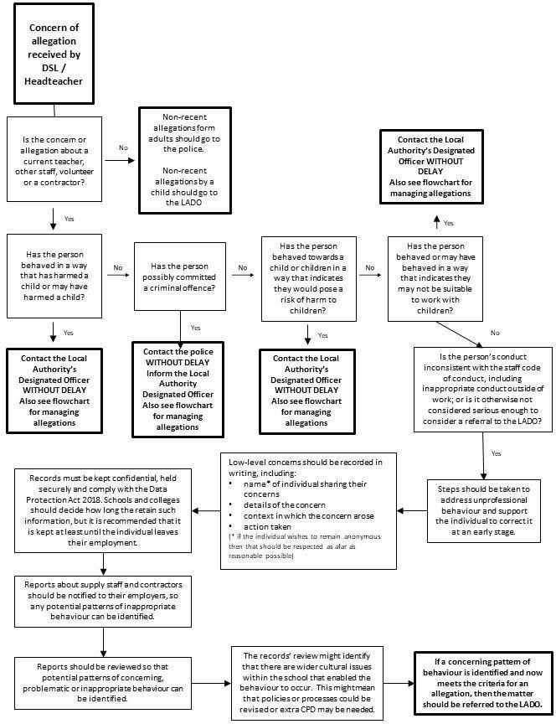
*NB – if the concern is about the Headteacher, then the CEO OLOW Academy Trust should be informed immediately.

- Low level Concerns Reporting Form (if online system is not available) – St Louis Catholic Academy

Your details
Name (optional)
Role
Date and time of completing this form
Details of individual (including yourself for self-reporting) whom the concern is about
Name
Role
Relationship to the individual reporting eg manager, colleague
Details of concern
Please include as much detail as possible. Think about the following: What behaviour and/or incident are you reporting? What exactly happened? Why does the behaviour and/or incident worry you? Why do you believe the behaviour and/or incident is not consistent with our Staff Code of Conduct?
Details of any children or young people involved
Name(s)
Next Steps
Are you willing to meet with the headteacher and DSL to discuss your concern? Please circle as  appropriate. | Yes | No
Please state any other information that you feel is relevant to the processing
of this concern.
Signature

For use by HT/safeguarding team upon receipt of the concern
Date and time concern received
Signature
Role
Actions to be taken and follow-up.

- References to other policies and legislation.

Keeping Children Safe in Education 2025
Working Together to Safeguard Children 2023
Guidance for Safer Working Practice 2022
OLOW Code of Conduct
OLOW Complaints policy
OLOW Disciplinary policy
CES Grievance policy

